Your First Book That Sells
  - How to Publish and Know What Every Sale Pays You on Kindle: Real Royalties, Honest Reviews, and a Catalog That Pays
Kevin Drew Peters
Updated 5 October 2026
Copyright © 2026 Kevin Drew Peters. All rights reserved.
No part of this publication may be reproduced, distributed, or transmitted in any form or by any means, including photocopying, recording, or other electronic or mechanical methods, without the prior written permission of the copyright holder, except in the case of brief quotations embodied in critical reviews and certain other noncommercial uses permitted by copyright law.
This book is a general educational guide. Amazon’s KDP terms, royalty rates, tax rules, and advertising tools change over time and differ by marketplace. Every platform rule in this book was checked against Amazon’s own help pages on 5 October 2026 and carries a numbered note that leads to the page. Verify the current figures before you rely on them, and get professional advice for your own tax and legal situation.
“Amazon,” “Kindle,” “KDP,” “Kindle Direct Publishing,” and “Kindle Unlimited” are trademarks of Amazon.com, Inc. or its affiliates. This book is an independent guide and is not produced, endorsed, or reviewed by Amazon.

Contents
How to Read This Book
Who this book is for
Why the arithmetic is always shown
How the book is built
The five labels
Part I — The Short Road: One Month with One Book
Start here
Chapter 1: Write one kind of book
Chapter 2: Name the reader
Chapter 3: The number you keep
Chapter 4: A page a stranger can trust
Chapter 5: Cover, keywords, and categories
Chapter 6: Ask for an honest review
Chapter 7: Find readers and send the copy
Chapter 8: Pick three ways to be paid
Chapter 9: A small ad test
Chapter 10: The next book
Chapter 11: Six calm weeks
Chapter 12: When the book is already live
Chapter 13: Words you can copy
Chapter 14: A filled money sheet
Chapter 15: The Kindle file
Do these seven things this week
Part II — The Landscape
Before the Full Guide
Chapter 16: Why Self-Publish
Chapter 17: How Amazon Actually Pays You
Chapter 18: Fiction and Nonfiction Take Different Paths
Part III — Writing and Producing the Book
Chapter 19: Choosing What to Write
Chapter 20: From Draft to Manuscript
Chapter 21: Formatting That Doesn’t Break Kindle
Chapter 22: Covers That Sell in a Thumbnail
Part IV — Getting Discovered
Chapter 23: Categories, Keywords, and Your Product Page
Chapter 24: Pricing for Profit
Chapter 25: Launching Without an Audience
Chapter 26: Amazon Ads Without Wasting Money
Part V — The Business Side
Chapter 27: Getting Paid: Taxes, Payments, and Reporting
Chapter 28: KDP Select vs. Going Wide
Chapter 29: Avoiding the Traps
Part VI — Playing the Long Game
Chapter 30: From One Book to a Catalog
Chapter 31: A Realistic First-Year Plan
Part VII — One Topic, in Depth
Chapter 32: The First-Review Problem
Part VIII — Using AI Well
Chapter 33: Using AI Without Losing the Business
A Closing Word
Appendix A — The One-Page Launch Checklist
Appendix B — Royalty Quick Reference
Appendix C — ISBNs, Wide Distribution, and Further Reading
Appendix D — Thirty-Two Ways a Book Can Pay You
Glossary
Notes
About the Author
Also by Kevin Drew Peters

How to Read This Book

Who this book is for
This book is for first-time and early independent authors who have written, or are writing, a serious ebook and want to publish it on Kindle without wasting money. You will learn to work out what one sale leaves you, price inside the right royalty band, ask for honest reviews the way Amazon allows, run a small capped ad test, and plan the second book that turns one title into a catalog.
It is not for everyone, and it says so now so you can decide before you spend an evening on it.
- It is not an advanced Amazon Ads manual. Chapter 26 stops at the first profitable campaign.
- It is not a writing-craft book. It will not teach plot, structure, or style.
- It is not a manual for publishing wide on every store. Chapter 28 helps you choose between KDP Select and going wide; the store-by-store work is left to those stores’ own guides.
- It is not a system for publishing many books quickly, with or without AI.
- It does not promise income. No method can, and this one does not try.

Why the arithmetic is always shown
Kevin Drew Peters is a graduate of Munich University of Applied Sciences. He spent many years in the semiconductor industry, most of them in the United States, supporting several start-ups. That work teaches a habit: measure before you decide, write the arithmetic down, change one variable at a time, and put a cap on the cost of every experiment.
This book applies that habit to Kindle publishing. What you will get: the platform rules with their sources and dates, the arithmetic behind every price and every ad, and small bounded tests you can run on your own book. What you will not get: the author’s own sales figures held up as proof, stories of overnight success, or a claim to know how Amazon ranks books. Amazon does not publish its ranking algorithm, and nobody outside Amazon has it.

How the book is built
Part I is the short road: fifteen short chapters, one action each, and a one-page plan for your first week. You follow one first-time author and her cozy mystery through one month. She is a teaching example, not a real person. If you read only Part I, you can publish honestly and know what each sale pays you.
Parts II to VIII are the full guide. They do not repeat Part I. Each chapter points back to the place where a rule is taught and adds what Part I left out: the marketplace detail, the edge cases, the reasons, and the tests. Part VII takes the first-review problem in depth, and Part VIII covers AI. The appendices hold a launch checklist, a royalty quick reference, thirty-two ways a book can pay you, a glossary, and the numbered notes.

The five labels
Every claim that could cost you money carries one of five labels.
Platform rule [n]. Something Amazon or another authority publishes, with a numbered note giving the page and the date it was checked. Rules change; the note tells you where to look.
Worked example. Hypothetical arithmetic with stated assumptions, usually a 2 MB file and no VAT. It shows how the sum works. It is not anyone’s result.
Field practice. What many authors report doing. It is common, not guaranteed, and not published by Amazon.
Recommendation. What this book advises, and why. You may disagree.
Test it yourself. A question that only your own book can answer, with a small, capped way to answer it.
Nothing in this book is a promise that you will earn a stated amount.

Part I — The Short Road: One Month with One Book

Start here
Picture a first-time author with a finished cozy mystery and a price of $0.99 in her head. She has not asked what one sale would leave her. Part I is the month she finds out. She is a teaching example, and every number in her month is a worked example, not a report.
Each chapter gives one action. Do it, then turn the page. The reasons, the exceptions, and the marketplace detail live in Parts II to VIII; Part I points to them and moves on.

The keep test
There is one method in this book, and it has three lines. Write them before you spend money or a week.
The keep. What one sale leaves you, from the royalty estimate in your KDP account. Until you have a file, use the practice number from Chapter 3 and write “practice” beside it.
The reader. Two sentences from Chapter 2: who the book is for, and who it is not for.
The date. The one change you will make, and the day you will look at the result. One change at a time is the whole discipline: if you change the price, the cover, and the ad on the same Monday, you will not know which one moved the money. Every later chapter that says “one change” means this line.
If a line is blank, do not pay for an ad, a promotion, or a stack of free copies.
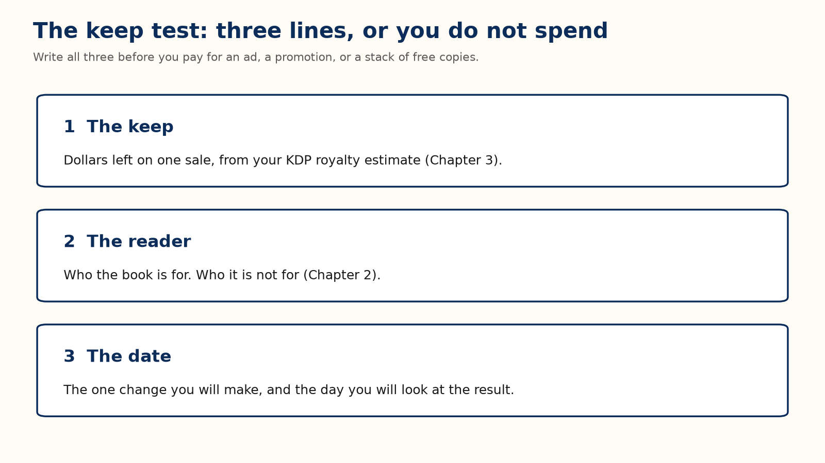

Chapter 1: Write one kind of book
The example book is a cozy mystery: one ferry office, one missing guest, one week, and the woman who keeps the office has to solve it. That is one kind of book. Her sentence for it is: a gentle mystery, a small town, no gore.
Write the one sentence you could print under your title. Then write one page for the path: what the reader knows at the start and what they know at the end. If you can retell your book only by listing someone else’s chapters, you copied a table of contents; invent your own.

Your action
One sentence for the form, one page for the path. Do not buy a cover while the manuscript is still two kinds of book.

Chapter 2: Name the reader
A cover, a price, and an ad each need one reader, not “people who like books.” Write two sentences:
This book helps or entertains [this reader] by giving them [this experience].
This book is a poor fit for people who want [something else].
Her pair reads: “This book entertains readers who like a gentle small-town mystery and a heroine who solves it without a gun. It is a poor fit for people who want a thriller, a romance with no puzzle, or a joke on every page.”
The second sentence matters as much as the first. A wrong-fit reader may return the book or leave a review saying the page promised something else.
Then look at five books your reader already buys and write down the words those books share and their readers use. For her shelf: small town cozy mystery, amateur sleuth inn mystery, clean mystery no gore, village puzzle mystery, quiet village detective. Those phrases come back in Chapter 5 and in the ad test. Never use another book’s title or author as one of your phrases.

Your action
Write the two sentences and the five shared phrases before Friday. If they are blank, do not buy traffic.

Chapter 3: The number you keep
Every later chapter that mentions “the keep” assumes you have done this sum.
The sticker price is not your money. The keep is what is left after Amazon’s share and, on the 70 percent option, a delivery charge.
Platform rule [3] [4]. On Amazon.com an ebook can earn 70 percent when its list price is between $2.99 and $12.99 and you select the 70 percent option. The top of that band was $9.99 until 7 July 2026, so older advice to stop at $9.99 is out of date. The 70 percent royalty is 0.70 × (list price − any VAT − delivery cost). VAT, value-added tax, is charged on ebook sales in some marketplaces outside the United States and is subtracted before the royalty percentage is applied; Amazon.com sales carry none. Delivery on Amazon.com is $0.15 per megabyte of the file as Amazon converts it. Outside the band, or on the 35 percent option, you earn 0.35 × (list price − any VAT), with no delivery charge.
Worked example. 2 MB file, so $0.30 delivery; no VAT; rounded to the cent.
List price | Option | Keep per sale
$0.99 | 35% | about $0.35
$2.99 | 70% | 0.70 × ($2.99 − $0.30) = $1.88
$3.99 | 70% | 0.70 × ($3.99 − $0.30) = $2.58
$4.99 | 70% | 0.70 × ($4.99 − $0.30) = $3.28
$7.99 | 70% | 0.70 × ($7.99 − $0.30) = $5.38

Whenever this book says “about $2.58,” it means the $3.99 line.
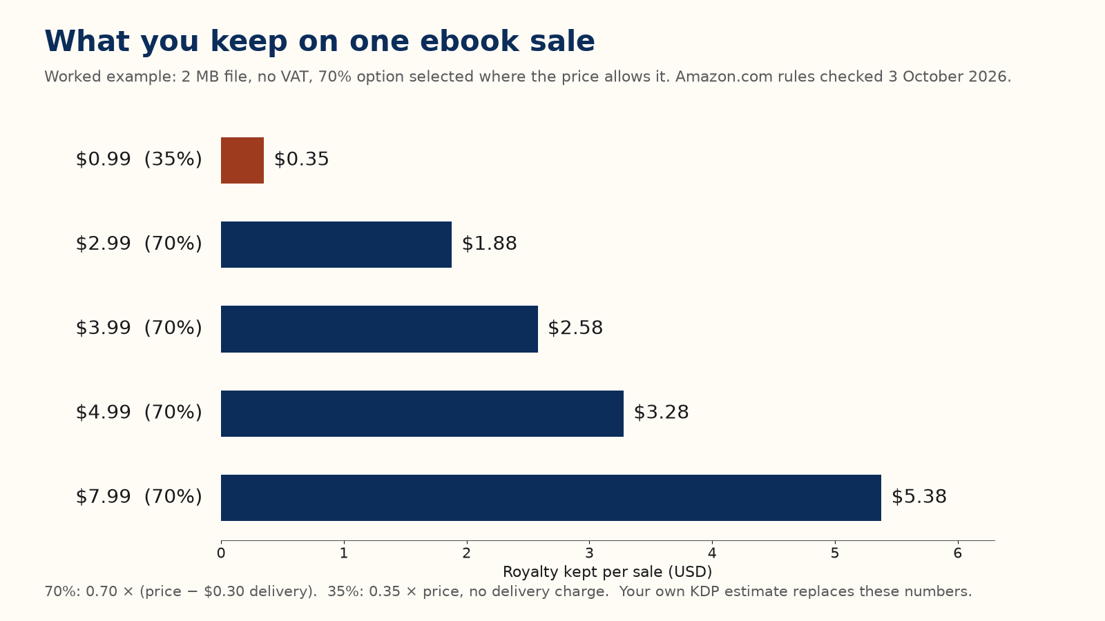
That table holds the $0.99 trap. A $0.99 sale keeps about $0.35; a $3.99 sale keeps about $2.58, more than seven times as much. Thirty sales at $2.99 keep about $56; twenty-five at $3.99 keep about $65. Fewer sales can pay you more.
Marketplace bands, the file-size minimums, Kindle Unlimited, and paperbacks are in Chapter 17. You do not need them to take this chapter’s action.

Your action
Open KDP’s royalty estimate for your real file and write the keep on your sheet. Do not price a book you spent months on at $0.99.
Her three lines now read. Keep: about $0.35 at $0.99 today; about $2.58 at $3.99. Reader: the two sentences from Chapter 2. Date: raise the price to $3.99, change nothing else, and look in four weeks.

Chapter 4: A page a stranger can trust
The cover, the description, the sample, and the book must promise the same thing. The first two sentences of the description do most of the work, because shoppers on a phone rarely reach paragraph four.
A weak opening: “This incredible novel will change your life. A must-read for everyone who loves a good story.” It names no reader and no promise.
Her opening: “The woman who keeps the ferry office knows every guest who comes and goes. When one vanishes and leaves a chess piece on the blotter, she has until Sunday to find him, without scaring off the wedding party in the dining room. A gentle mystery for readers who want a small town, a puzzle, and no gore.”
Then open your sample on a phone and count the screens before the reader reaches what they came for. A tunnel of front matter is a reason to close the sample.

Your action
Show your first two sentences to one stranger. If they cannot say who the book is for, rewrite them before you touch the cover or buy an ad.

Chapter 5: Cover, keywords, and categories
The thumbnail test. Shrink your cover until it is about the size of a postage stamp, or look at it on your phone’s screen at arm’s length. You must still read the title, and you must still know what kind of book it is. A quiet mystery should not look like a thriller or a textbook. Do not rely on colour alone; some screens show the cover in gray. If the title fails, the rest of the design does not matter yet. Chapter 22 covers genre conventions, hierarchy, and what covers cost.
Keywords. KDP gives you seven keyword boxes. Fill them with short phrases a reader would type, like the shared phrases from Chapter 2, not single words such as “book.” Her seven: small town cozy mystery, amateur sleuth inn mystery, clean mystery no gore, village puzzle mystery, quiet village detective, gentle puzzle novel, weekend mystery book.
Categories. You choose up to three. Pick the closest true shelves where your five comparison books sit, not the biggest shelf in the store. Chapter 23 has the rules and the reasons.

Your action
Run the thumbnail test on your phone today. If the title fails, fix the cover before launch week.

Chapter 6: Ask for an honest review
Platform rule [1] [2]. You may give readers a free or discounted copy as long as you do not require a review and do not try to influence it. Offering anything else in exchange for a review, including a gift card, refund, or service, makes that review ineligible under Amazon’s policy. Amazon does not allow reviews from the author, or from friends, relatives, employers, business associates, competitors, or anyone with a financial interest in the book. Do not buy reviews, trade reviews with other authors, or ask anyone to change a rating.
Platform rule [22]. In the United States the FTC’s rule on consumer reviews, in force since 21 October 2024, forbids a business from offering an incentive on condition that the review be positive, whether that condition is said out loud or implied.
So the request is simple, and it is the same for every reader: a review is welcome, optional, and honest, with no rating requested. Some readers will not finish. Some will finish and say nothing. Both are allowed.
A bad line: “I gave you this book, so please post five stars by Friday or I cannot send you the next one.” A clean line: “An honest review after publication is welcome and optional. No rating is requested. You can stop reading or say nothing.”
Not every willing reader can post on Amazon; Chapter 32 explains who can, and why many cannot.

Your action
Delete any line in your invitation that sounds like a trade. Do not pay any service that promises stars.

Chapter 7: Find readers and send the copy
The best advance reader already likes this kind of book and has time this month. Start with people who asked to hear from you, then communities whose rules allow a polite invitation. Do not scrape addresses, and do not add anyone to a list because they once said hello.
Tell them the subject, the length, the format, and the dates, and give them a way to decline. Collect a name, an email, the format they want, and one question about fit. Put any newsletter opt-in in a separate checkbox.
Worked example. Plan for a low response. Of 30 copies, 10, 20, or 30 percent posting would be 3, 6, or 9 reviews. Plan so that the low end is fine; readers owe you nothing.
She sent her copy to a reader who had asked for a thriller. He wrote back that the chess piece wasted his evening. She had skipped the sentence about who the book is not for.
Send four notes at most: a confirmation, the file, the store link once reviews can be posted, and one gentle follow-up. Chapter 13 has the words. If your ebook is in KDP Select, or about to be, read Chapter 28 before you email it; a public giveaway of the full ebook can break the exclusivity terms.

Your action
Write the invitation with the “not for” sentence in it, and send the file to one willing reader before you send it to the group.

Chapter 8: Pick three ways to be paid
A book can pay you in many ways, and Appendix D lists thirty-two, each with its smallest version and the number that means stop. This month, pick only three: one price, one next book (even if it is only a sentence), and one format or short extra.
Run each through the keep test. Write the keep for that product. Pick the smallest version that can still teach you something. Write the day you will look. On that day, keep it or stop it in one sentence on your money sheet, such as “Held the $3.99 price” or “Stopped the free days; no second book yet.”
Worked example. Her first idea is the price. At $0.99 she sold 20 copies in four quiet weeks and kept about $7. She changed only the price, to $3.99, and over the next four weeks sold 12 copies and kept about $31. Fewer sales, more money. She held the price four more weeks before believing it.

Your action
Circle three ideas in Appendix D, one of each kind, and write a look-date next to each.

Chapter 9: A small ad test
Chapter 26 adds campaign structure and ACOS; it does not repeat the cap.
You do not need many reviews to run a tiny test. You do need a cover that passes the thumbnail test, two true description lines, and a keep written down.
Worked example. She keeps about $2.58 on a $3.99 sale. A click costs $0.30. If one click in ten becomes a sale, the ad spends $3.00 to earn $2.58. The most a click can cost is the keep times the conversion rate: $2.58 × 0.10 = about $0.26. At 5 percent the ceiling is about $0.13. These are ceilings, not bids.
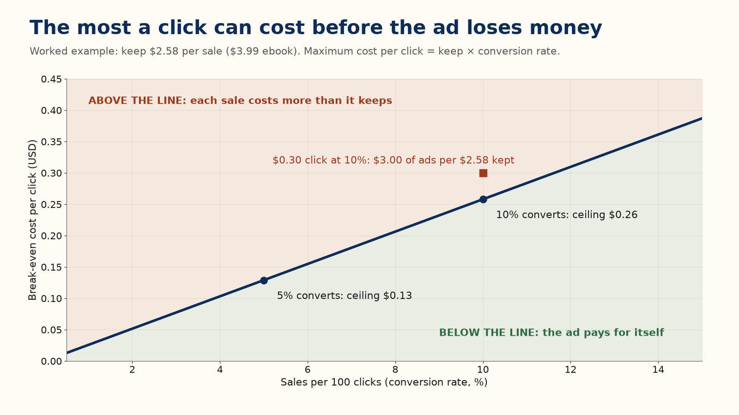
Recommendation. Use one Sponsored Products campaign. Set a total cap you can afford to lose, such as $20 to $60, and write the stop date before you turn it on. Stop at the cap even if you are curious; curiosity is not a budget.
Her fourteen-day log, with a $40 cap: on day 0, write the keep, the cap, the stop date, and five phrases. On day 3, look and change nothing. On day 7, if almost nobody clicked, change the cover or the phrases, not the cap. On day 14, or at $40, stop, and write sales, spend, and keep.
When you look, read in this order. Impressions but few clicks: the cover or targeting is wrong. Clicks but no sales: the page, the sample, or the price does not match the ad. Sales that keep less than they cost: lower the bid or pause. Page-read money, if you are in Kindle Unlimited, goes in its own column.

Your action
Write the keep, the cap, and the stop date before you open the ads console. If any is blank, do not start.

Chapter 10: The next book
One book can pay you a little. A second book can pay you again from a reader who already trusts you. That is not a reason to lose money on book one today; if book one loses money, book two is a second product, not a refund.
Worked example. 100 people buy book one at $3.99 and she keeps about $258. Thirty of them later buy book two at the same keep: about $77 more. That is about $335, or $3.35 per first buyer. If half of those 30 buy a third book, 15 more sales add about $39, for about $3.74 per original buyer. Paying $2 to find a buyer can fit; paying $4 does not. Never count a series as if every reader buys every book. The 30 percent who return is an assumption for this sum, not a rate to expect; real read-through varies by genre and by how good book one actually was, and only your own second book’s sales will tell you yours.

Your action
Write one sentence for book two: who it is for and why a reader of book one would want it. If you cannot, leave book one at its ordinary price.

Chapter 11: Six calm weeks
Move these dates if the book is not ready. A late, finished book beats an on-time file you are ashamed of.
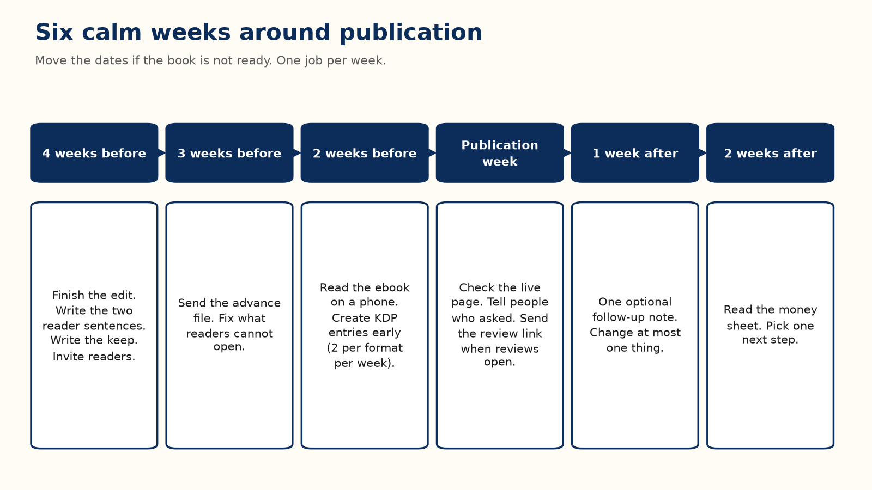
Four weeks before: finish the edit, write the reader sentences and the first two description lines, write the keep, set the most you can lose, and invite advance readers. Three weeks before: send the advance file and fix what readers cannot open. Two weeks before: read the ebook on a phone and create your KDP entries; KDP lets you create only two new titles per format each week (Chapter 15). Publication week: check the live page, tell the people who asked, and send the review link once reviews can be posted. One week after: one optional follow-up note, and at most one change. Two weeks after: read the money sheet and pick one next step.

Your action
Put these six dates in your calendar today.

Chapter 12: When the book is already live
A slow book rarely explains itself. Find the first broken step, fix only that, and leave the later steps alone for two weeks.
Nobody can tell what the book is: fix the cover (Chapter 5) or the first two lines (Chapter 4). The right people never see it: change the categories and phrases. People open the sample and leave: move the reader faster to what they came for. Readers name the same flaw: believe the pattern, fix the book, and do not argue in public. Sales happen and you still lose money: compare the keep with the ad spend, pause the spend, and test the price by itself.
Pick the number that will tell you the fix worked before you start: two strangers read the title at thumbnail size; two strangers can say who the book is for; the keep on the sheet moved for a reason you can name.

Your action
Name the earliest broken step, change only that, and write the look-date.

Chapter 13: Words you can copy
Replace the brackets. These are your words to readers; never write their review for them.

Public invitation
I am inviting readers who enjoy [subject] to receive a free advance copy of [Title]. It is [one true sentence, and its length], planned for [date]. If it fits and you have time during [dates], you can ask for a copy here: [link]. An honest review later is welcome and optional. No rating is requested. You can stop or say nothing.

Confirmation
Thank you for asking about [Title]. I plan to send the [format] file on [date]. Publication is planned for [date]. You can opt out at [how]. The free copy does not require a review.

Delivery
Your copy of [Title] is here: [link]. To open it, [steps you have tested]. If it fails, reply with what you see and I will help. I will send the store page when the book is live and reviews can be posted. Please do not pass the file on.

The live page
[Title] is available here: [link]. If you have read it and want to leave an honest review, use the review option on that page. Reviewing is optional. If you review, please mention that you received a free advance copy.

One follow-up
A last note about [Title]. If you finished and want to leave an honest review, the page is [link]. If you already did, thank you. If you would rather not, that is fine. I will not ask again about this book.

Inside the book
Thank you for reading. If you want to help another reader decide whether this book suits them, you can leave an honest review where you found it. It is optional. What you actually thought is the useful part.

First two lines you can adapt
For a novel: “[A character] wants [ordinary goal]. When [event] happens, they have until [deadline] to [action], without [cost they refuse to pay]. A [genre] for readers who want [three concrete tastes].”
For a guide: “This book helps [specific reader] do [specific job] without [the pain they already have]. You will leave with [the concrete thing]. It is a poor fit if you want [the opposite].”

Chapter 14: A filled money sheet
Copy this shape and fill in your own lines. Her numbers are a worked example, not a report.
Line | Her month (worked example) | Yours
Book and price | Cozy mystery, $3.99
Keep per sale | about $2.58
Copies hoped for | 40 (about $103 kept)
Ad cap and stop date | $40, the 28th
Paid copies | 22
Money kept | about $57
Money spent on ads | $40
Left after ads | about $17
Editor and cover still unpaid | $600
Page reads | none (not in Select)
The one change | the ad, nothing else
The day you look | in two weeks

A useful sentence for the bottom: “$3.99, keep about $2.58, ad stopped at $40, cover still unpaid; the description is the next test.” A useless one: “Ads don’t work.” You know this month. You do not know ads.

Chapter 15: The Kindle file
The Word file is not what the reader sees. Open KDP’s previewer and read the book on a phone-sized screen with the type larger than you like. Use real heading styles so the contents links work, give every picture words a screen reader can use, and replace any table that smears on a phone.
Before you press publish, check the title, subtitle, author name, description, cover, categories, keywords, territories, and price, then copy KDP’s royalty estimate onto your sheet in place of this book’s rounded examples.
Three more rules belong on the same checklist.
Platform rule [8]. Each time you publish or republish, KDP asks whether the book contains AI-generated text, images, or translations. Answer for what you actually did. Chapter 33 gives the full rule and a decision chart.
Platform rule [11]. KDP currently limits title creation to two titles per format each week. That means up to two ebooks, two paperbacks, and two hardcovers in a week. Check the live help page before planning a larger release schedule.
Platform rule [12]. Since 20 January 2026, if you publish without DRM, verified buyers can download the book as EPUB and PDF files and read it on other devices. Kindle Unlimited borrowers cannot. Choose the DRM setting on purpose.
Finally, have one other person open the ebook, jump to a chapter, and come back to the contents. Do not announce the book until they can find their way without you.

Your action
Read the whole preview on a phone, fix the first thing that breaks, and write KDP’s estimate on your sheet.

Do these seven things this week
One page, one week, whether your book is still a file or already live.
1. Day 1. Write the keep from KDP’s royalty estimate (Chapter 3).
2. Day 2. Write the two reader sentences and the first two description lines (Chapters 2 and 4).
3. Day 3. Run the thumbnail test on your phone and note whether the title passes (Chapter 5).
4. Day 4. Choose up to three true categories and seven reader phrases (Chapter 5).
5. Day 5. Read the sample on a phone and fix the first place a reader would stop (Chapters 4 and 15).
6. Day 6. Circle three ideas in Appendix D and date them (Chapter 8).
7. Day 7. Fill the money sheet with this week’s real numbers, even if they are zero, and write the one change with its look-date (Chapter 14).
When all seven are done, Parts II to VIII are there for the questions this week raised. Jump to the chapter that matches the line on your sheet that is still hardest to fill.

Part II — The Landscape

Before the Full Guide
Part I walked one book through one month with one action per chapter. The full guide goes back over the same ground in production order and adds what Part I left out: the edge cases, the marketplace detail, the reasons, and the tests. It does not re-teach Part I. Where a rule was given there in full, the chapters here name the chapter and assume the figure is already on your sheet.
One thing comes before every chapter that follows: categories, keywords, price, ads, and reviews only work on a book a reader wants to finish. No amount of keyword research rescues a book that does not keep its cover’s promise.

Chapter 16: Why Self-Publish
Self-publishing through Kindle Direct Publishing (KDP) turns a long chain of agents, editors, and contracts into one step: you upload a file, set a price, and the book usually goes on sale within about 72 hours, with no one’s permission but your own. The barrier to publishing dropped to almost nothing. The barrier to publishing well did not move. This book is about the second barrier.

The three doors
Traditional publishing pays an advance and a royalty set by contract, provides editing, design, and distribution, and takes control of price, cover, and timing. It moves on a timeline of years, and for a debut author without a platform the door is narrow.
Hybrid and vanity publishers charge the author to publish. A few are transparent about what each fee buys. Many charge high prices for things that cost little or nothing to do yourself, such as an ISBN, an ebook conversion, or a KDP upload. Chapter 29 shows how to tell them apart.
Self-publishing makes you the publisher. Nobody stops you and nobody helps you, unless you hire the help. In exchange you keep your rights, earn the royalties in Chapter 3 and Chapter 17, and can change a price or fix a typo the same day. The cost is that editing, cover, formatting, metadata, pricing, launch, and advertising become your job, in your own hours or your own money.
Recommendation. Treat self-publishing as a small business from the first book: hire or barter for the editing you cannot do, design the cover for its shelf, and keep records. The platform is the same for every author; what differs is how well the job is done.
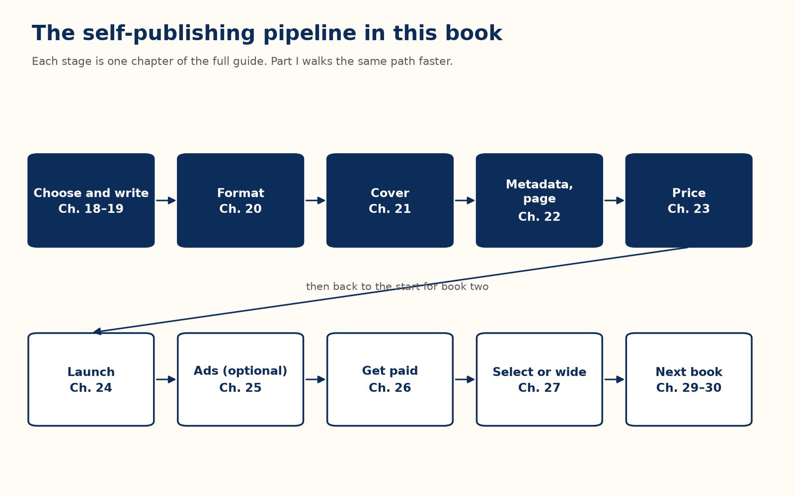

Doing both
The paths are not exclusive across a career. Some authors self-publish first and later sign with a publisher; others get rights back on an out-of-print book and republish it themselves. Nothing here asks you to choose forever.

Chapter 17: How Amazon Actually Pays You
Chapter 3 covers the per-sale keep; this chapter assumes that figure is on your sheet and adds what Chapter 3 left out: the edge cases of the ebook royalty, other marketplaces, Kindle Unlimited, and print.

The ebook royalty: the details behind the cliff
Platform rule [3] [4]. These conditions all apply to the 70 percent option on Amazon.com:
- It applies only to sales in Amazon’s listed territories. Sales elsewhere earn 35 percent.
- For sales to customers in Brazil, Japan, Mexico, and India, the ebook must also be enrolled in KDP Select (Chapter 28) and priced inside that marketplace’s 70 percent band.
- Your ebook list price must be at least 20 percent below the Amazon list price of any print edition of the same book.
- Books that consist mainly of public-domain content earn 35 percent only.
- If Amazon matches a lower price found elsewhere and that price falls below the 70 percent minimum, the sale earns 35 percent.
- The July 2026 band change did not switch anyone automatically. A book already on the 35 percent option and priced between $2.99 and $12.99 stays there until you change it in your pricing settings.
The 35 percent option has its own floor, which depends on file size. On Amazon.com the minimum list price is $0.99 for files under 3 MB, $1.99 from 3 MB to under 10 MB, and $2.99 at 10 MB or more. The maximum is $200.
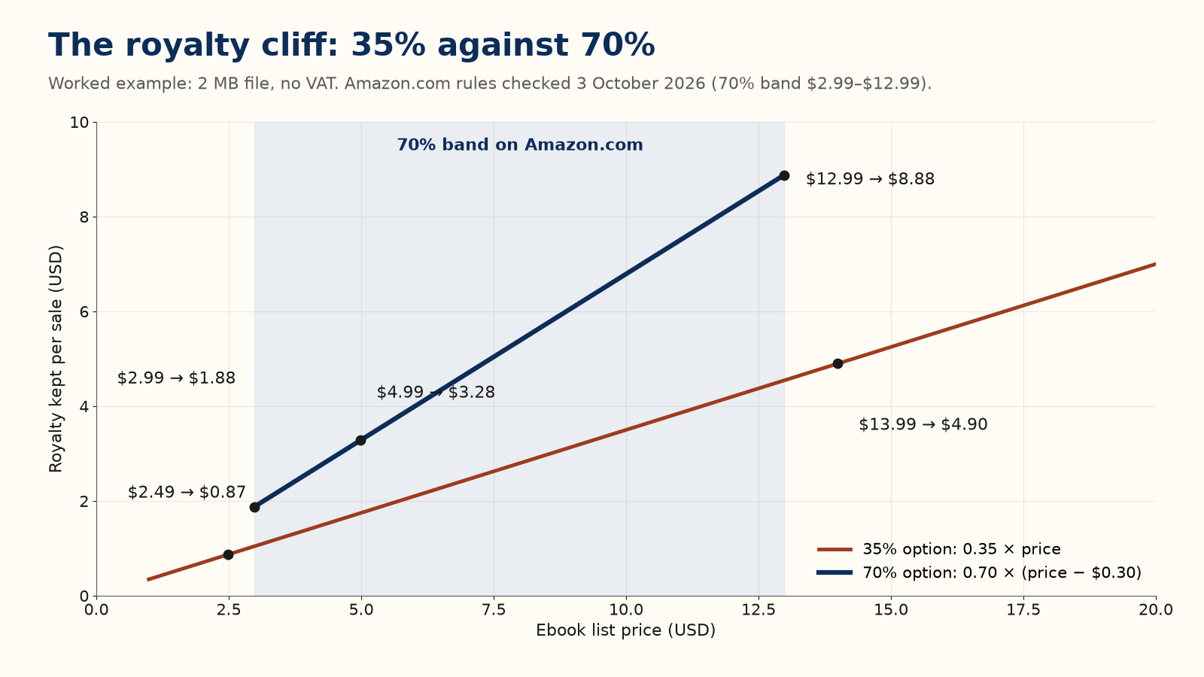
That figure is the cliff. Priced one cent outside the band, the rate does not taper; it halves.
Worked example. At $4.99, a 2 MB file keeps $3.28. Priced instead at $2.49, below the band, it keeps 0.35 × $2.49 = $0.87. Cutting the price by $2.50 cut the keep by $2.41. At $13.99, just above the band, it keeps 0.35 × $13.99 = $4.90, less than the $8.88 kept at $12.99.
Worked example. File size matters more than most authors expect. A 20 MB illustrated book at $9.99 pays $3.00 delivery on Amazon.com, so it keeps 0.70 × ($9.99 − $3.00) = $4.89, not the $6.78 a 2 MB file would keep. Compress images before you trust any keep, and use KDP’s estimate for your actual file.

Other marketplaces
Platform rule [3] [4]. Each marketplace publishes its own band and delivery rate in its own currency. Examples, checked 5 October 2026:
Marketplace | 70% band | Delivery per MB
Amazon.com | $2.99–$12.99 | $0.15
Amazon.co.uk | £1.77–£12.99 | £0.10
Amazon.de, .fr, .es, .it, .nl | €2.69–€12.99 | €0.12
Amazon.ca | C$2.99–C$12.99 | C$0.15
Amazon.com.au | A$3.99–A$15.99 | A$0.15

EU prices include VAT, and the royalty is figured on the price without VAT, so the same-looking price keeps less. Set each marketplace’s price from its own page, not from a currency converter.

Kindle Unlimited and the page-read fund
Platform rule [13] [10]. If your ebook is in KDP Select, Kindle Unlimited subscribers can borrow it and you are paid for pages read, measured in Kindle Edition Normalized Pages (KENP), not your Word page count. Each month Amazon sets a KDP Select Global Fund, splits it among countries, and divides each country’s share by the pages read there. You can earn for at most 3,000 pages per title per customer. For July 2026 Amazon announced a fund of $67.6 million. KDP also runs a separate, discretionary monthly All Stars bonus for Select titles that reach certain customer-engagement marks, with its own pool size announced alongside the fund each month. Amazon does not publish a single per-page rate; your own royalty report shows what your pages earned, and monthly figures are finalised around the 15th of the following month.
Worked example. At a hypothetical $0.0045 per page, one full read of a 300-page (KENP) book pays 300 × $0.0045 = $1.35. That is less than the $3.28 kept on a $4.99 sale, but it may come from a reader who would never have paid $4.99. Whether that trade suits your book is the question in Chapter 28.

Print: paperback and hardcover
Platform rule [7] [19]. A print royalty is (rate × list price) − printing cost. The printing cost is subtracted after the rate, not multiplied by it. On Amazon.com the rate is 60 percent at a list price of $9.99 or more and 50 percent at $9.98 or less, for both paperbacks and hardcovers. Other marketplaces draw the line elsewhere: £7.99 in the UK, €9.99 in the eurozone, C$13.99 and A$13.99 in Canada and Australia. Paperbacks sold through Expanded Distribution earn 40 percent minus printing cost; Expanded Distribution is not offered for hardcovers, which sell only directly through Amazon. Printing cost depends on the marketplace, page count, and ink type (and, for hardcovers, trim size). KDP sets a minimum list price so the royalty can never be negative.
Worked example. A paperback with a $4.00 printing cost: at $14.99 it keeps (0.60 × $14.99) − $4.00 = $4.99; at $8.99 it drops to 50 percent and keeps (0.50 × $8.99) − $4.00 = $0.50. Through Expanded Distribution at $14.99 it keeps (0.40 × $14.99) − $4.00 = $2.00. Use KDP’s calculator for your real printing cost.

Reading your own numbers
Policy changes; your reports describe your own book. Chapter 27 explains which report to trust for what. Read them weekly during a launch and monthly afterwards.

Chapter 18: Fiction and Nonfiction Take Different Paths
Part I followed one book from one genre: a cozy mystery. The arithmetic before it — the keep, the royalty bands, the ad cap, the review rule — does not know or care what genre you write. Everything from here forward, though, is production order, and a few of the methods ahead do fork by whether your book is a story or a guide. This chapter names the forks once, so Parts III to VIII do not have to qualify every sentence.

Shelves and keywords point at different things
Recommendation. Fiction categories sit on a genre and subgenre shelf (Mystery, then Cozy; Romance, then Contemporary); a reader there is choosing a kind of story. Nonfiction categories sit on a topic or professional shelf (Business & Money, Health, Reference); a reader there is choosing a kind of help. The three-category rule and the “closest true shelf, not the biggest one” advice in Chapter 23 apply to both, but the shelf you are matching your book against looks different depending on which one you are writing.
Keywords follow the same fork. Chapter 23’s seven-box rule is identical either way, but the phrases that fill it are not: a fiction reader searches on genre, trope, and feel — “cozy mystery,” “slow burn romance,” “clean fantasy no gore” — while a nonfiction reader searches on problem and outcome — “meal prep for beginners,” “SQL for data analysts,” “first apartment budget.” Write your seven for the reader you actually have, not for the example in Chapter 5.

The hook changes what it promises
Chapter 4’s two-sentence test still applies to both: a stranger should be able to say who the book is for from the first two lines. What those two lines promise is where fiction and nonfiction split. A novel’s hook promises a character, a stake, and a genre feeling, the way Part I’s ferry-office mystery does. A nonfiction hook promises a problem solved and a reason to trust the person solving it, the way Chapter 23’s “why this author can deliver it” shapes a nonfiction description. Neither hook benefits from borrowing the other’s shape; a guidebook opening with “when one vanishes” confuses the shopper it is trying to reach.

Reviews ask different questions of the same rule
Platform rule [1] [2]. The review rule itself does not change: optional, honest, no rating requested, the same roster-and-invitation method from Chapters 6 and 7 for every genre. What changes is what you are screening advance readers for. A novel needs readers who read in that genre and will judge the story on its own terms. A nonfiction book needs readers who either have the problem it solves or enough standing in the subject to judge whether the solution actually works; a glowing review from someone who never had the problem is worth less than a flat one from someone who did.
Field practice. Nonfiction authors often publish from an existing platform — a blog, a podcast, a channel — built before the book exists. Pat Flynn’s Smart Passive Income site, built years before his own books, is a widely known example of an audience preceding the book rather than the book building the audience cold, the way Part I’s launch does for a debut novelist with no list yet. Neither path is required, and the launch chapters (Chapters 6, 7, and 25) assume no existing audience on purpose; a platform mainly changes which of those steps you have already done before you start.

A catalog means something different in each case
Chapter 10’s book-two arithmetic holds for both, but “book two” is not the same idea. A fiction catalog usually continues a world or a character, so a reader who liked book one is choosing more of the same story engine. A nonfiction catalog more often ladders by level (a beginner guide, then an intermediate one) or spreads sideways across separate problems for the same reader (Chapter 30 has both shapes). Plan your next book as the kind of sequel your own genre actually rewards, not as a copy of Part I’s example.

What does not change
Price bands, delivery charges, the review rule, the ad cap, the AI-disclosure rule, and every number in this book apply exactly the same way regardless of genre. Only the shelf, the keywords, the hook, the reader screen, and the shape of a catalog fork. Chapter 24 gives the price ranges that happen to differ by category of book; that is a pricing question, not a different set of royalty rules.

Part III — Writing and Producing the Book

Chapter 19: Choosing What to Write
“Write the book only you can write” is good advice and a weak business plan on its own. A book that sells sits where two things meet: something you can write well, and something a group of readers is already looking for. Amazon’s own store is a free research tool for finding that meeting point.

Four checks in the store
Field practice. These are common checks, not Amazon rules. In the category you are considering:
- Compare Best Sellers with Hot New Releases. Long-standing bestsellers show past demand; recent releases that already have reviews show demand now.
- Compare review counts with publication dates. Many reviews on an old book show the category had readers; a fair number on a book a few months old shows readers are buying now.
- Look at who publishes there. A shelf held by a few large publishers with deep backlists is hard to enter. A shelf of single-book authors is easier to be seen on, though sometimes it is fragmented because demand is small.
- Read the one- and two-star reviews of the current leaders. They tell you what readers wanted and did not get. That gap can become your outline.
Field practice. A hypothetical beginner’s hobby guide: the top of the list is held by three books six to ten years old; two books published in the last 90 days already have dozens of reviews; four single-book authors sit in the top twenty; and the low-star reviews of all three leaders complain that there is no troubleshooting for humid climates. None of that guarantees a sale. It does give you a shelf with live buyers and one checkable gap to lead with in your subtitle and description (Chapter 23).

Write to a shelf
Writing to a shelf means knowing, before you draft, which existing shelf your book belongs on and what a reader there expects. It is the opposite of chasing a trend: by the time a trend shows on the charts, many authors have seen it. A book for one clearly defined reader, with a specific level, goal, and constraint, gives its cover, title, and sample one message to send.

Standalone or series
A standalone earns once per reader. A series or a set of related guides can earn again when a reader finishes one and buys the next. Chapter 10 shows the arithmetic; Chapter 30 shows how a catalog extends it. For nonfiction, a beginner, intermediate, and advanced set, or books that each solve one part of a larger problem, work the same way.

Chapter 20: From Draft to Manuscript
A finished draft and a finished manuscript are not the same object. The gap between them is where most self-published books lose readers, because the person who wrote a book reads what they meant, not what is on the page.

The passes, in order
- Developmental edit: is the structure right, with nothing important missing and nothing repeated?
- Line edit: does each paragraph read well, at the right level for the stated reader?
- Copyedit: grammar, consistency of names, numbers, and capitals, and a check of every fact a reader could look up.
- Proofread: the last pass, on the near-final formatted file, catching typos and accidents introduced by editing.
These are different skills. Recommendation. If you can hire only one, hire the copyedit; it catches the errors readers notice consciously.

A minimum revision checklist
- Read the book aloud, or have text-to-speech read it to you.
- Check every number and every cross-reference after the last reorganisation.
- Run one adversarial pass, looking only for claims you cannot back up and promises the book does not keep.
- Give the book to one reader who has never seen it and ask where they got confused or bored.
- Run at least one pass that is not simply reading again: a fact-check against sources, a search for repeated words, or a consistency script.
AI tools can help with some of these passes. What KDP requires you to disclose, and who owns AI-written text, are in Chapter 33. Whatever tools you use, a person accountable for the book makes the last call on every sentence and every number.

Chapter 21: Formatting That Doesn’t Break Kindle
Ebook formatting and print formatting solve different problems. Treating one file as correct for both is how books end up with a page reference that means nothing on a phone, or a paperback with no page numbers.

Ebooks: let the reader’s device do the layout
A Kindle reader can change font, size, and spacing, so a reflowable ebook has no fixed pages. That has three consequences.
- Use real heading styles (Heading 1, Heading 2), not bold text that only looks like a heading. KDP builds the book’s navigation from a proper table of contents, and Word or Kindle Create builds that table from heading styles.
- Do not number pages in the contents and do not refer to “page 47.” Refer to chapters and sections instead.
- Skip a print-style index. If a reference book needs one, that is a reason to offer a print edition.
Keep the rest plain: standard paragraph styles, images sized to work on a phone, and no text boxes or multi-column layouts. Check the book in KDP’s previewer at more than one device size before you publish. The Kindle Publishing Guidelines are the full rulebook [9].

Print: everything the ebook did not need
- A contents page with page numbers, because print pages are fixed.
- Page numbers and, usually, running headers.
- Front matter in the expected order: title page, copyright page, optional dedication, contents, then the text.
- A trim size; 6 × 9 inches is common for nonfiction, 5.5 × 8.5 inches for shorter guides.
- Margins with room for the gutter, which grows with page count.
- Bleed only if something prints to the edge of the page.
- A cover sized with KDP’s cover calculator and template, because spine width depends on page count, paper, and ink.
- A printed proof, ordered and read before you publish.

Chapter 22: Covers That Sell in a Thumbnail
Chapter 5 gives the thumbnail test; this chapter assumes your title passes it and covers what the test does not.

Genre conventions exist because readers use them
Shoppers scan a category page by pattern: they have learned what a thriller looks like, and what a business book looks like. Recommendation. Before you commission or design a cover, open the current bestsellers in your exact subcategory and note what they share: palette, type weight, how much is image and how much is type, and where the author name sits. Break a convention only on purpose, after you know what it signals.

Hierarchy: title, subtitle, author
For most nonfiction the eye should move from title (the hook) to subtitle (the specific promise) to author name. Put your name first only if readers already search for it. If all three are the same size, the eye has nowhere to start.
Platform rule [17]. The title, subtitle, and author name on the cover must match what you enter in KDP, and a cover may not closely imitate another book’s layout, colours, fonts, or images.

DIY, template, or designer
- KDP’s Cover Creator is free and recognisable as a template: fine for testing, rarely enough for a book you will advertise.
- Premade templates and freelancers working from a brief range, as field practice, from tens of dollars to a few hundred, and can look professional if the template was built for your genre.
- A designer who works in your category costs more, often several hundred dollars and up, and knows the conventions without being told.
Whichever you choose, the finished cover goes through the thumbnail test before you pay the final invoice.

Part IV — Getting Discovered

Chapter 23: Categories, Keywords, and Your Product Page
A shopper finds a book by searching or by browsing. Keywords serve the first path, categories the second, and the product page turns either kind of visit into a sale. All three are free to set and free to change.

Keywords
Platform rule [18] [17]. KDP gives you up to seven keywords or short phrases; KDP recommends phrases of two or three words. KDP asks you to avoid:
- words already in your title, contributor names, or chosen categories;
- claims about quality or rank, such as “best” or “bestselling,” and promotional words such as “free”;
- time-sensitive words such as “new” or “on sale”;
- other authors’ names, other books’ titles, and brands you do not own;
- Amazon program names such as “Kindle Unlimited” or “KDP Select.”
Misleading keywords are not a grey area; KDP states a zero-tolerance policy for metadata meant to mislead.
Recommendation. Build your seven from two free sources: the suggestions that appear as you type in Amazon’s search bar, and the words readers use in reviews of comparable books. Search each phrase on Amazon before you keep it; if the results are not books like yours, drop it. Keywords can be changed as often as you like, so revisit them once the book has a few weeks of data.

Categories
Platform rule [15]. You choose up to three categories in KDP, based on your primary marketplace and audience, and you can change them later under Edit details; a change can take up to 72 hours to show. Categories differ by marketplace and format. KDP may move a book whose category does not match its content, and KDP Support does not recommend categories.
Field practice. Many authors choose the most specific true category they can, because a book with modest sales is more visible near the top of a small category than lost in a large one, and a high place in a small category can earn a “Best Seller” badge on that category’s list. Amazon does not publish how its ranks are calculated. Recommendation. Choose for accuracy first; a wrong shelf brings the wrong readers, and KDP does not tolerate misleading categorisation.

Your product page
Platform rule [30] [17]. The description field holds up to 4,000 characters, including any HTML tags, and supports simple formatting such as bold, italics, headings, and lists. It may not contain review quotes or testimonials, requests for reviews, prices or availability, time-sensitive offers, links, or keyword lists.
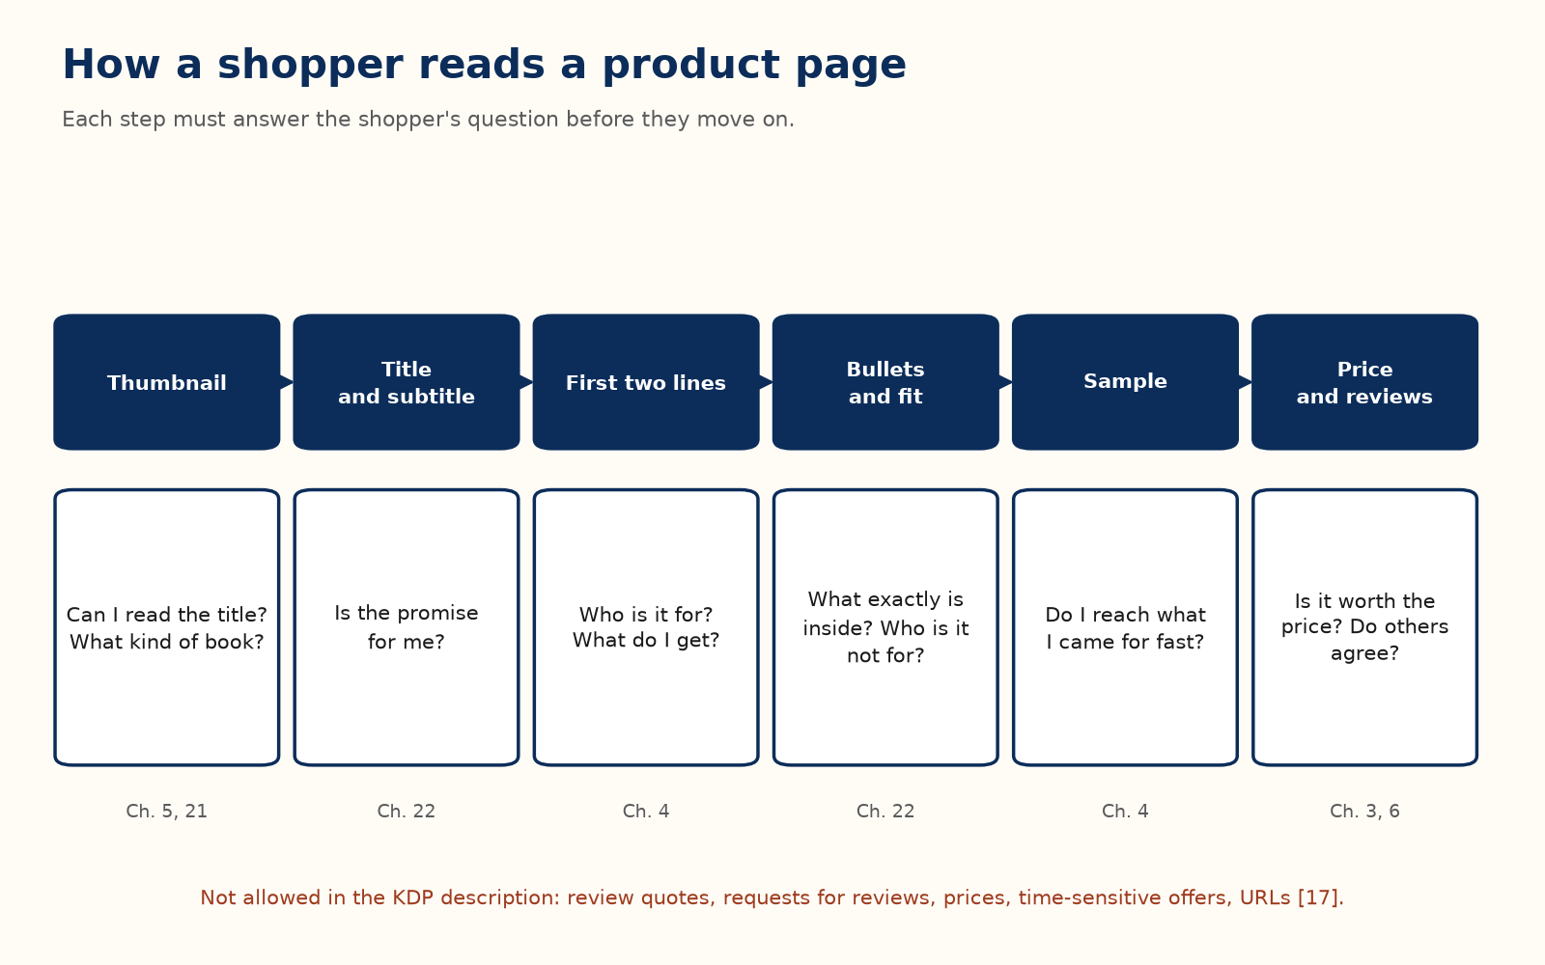
Recommendation. A shape that works for most nonfiction:
1. A hook of one or two sentences naming the reader’s problem or goal (Chapter 4).
2. One short paragraph on what the book delivers and why this author can deliver it, stated truthfully.
3. Five to eight concrete bullets: “the exact price where the royalty rate halves,” not “learn about royalties.”
4. One line saying who the book is for and who it is not for (Chapter 2).
Worked example. Before: “This book covers how to publish on Amazon KDP. It talks about royalties, pricing, categories, keywords, and marketing.” After: “Most first books lose money for a reason that has nothing to do with the writing: nobody showed the author what one sale pays. This guide shows the arithmetic every time. Inside: the price where your royalty rate halves; the keyword mistakes KDP itself warns against; a break-even test you can run before you spend on ads. For first-time authors of a serious ebook; not for advanced advertisers.” Same facts, but the reader and the promise now come first.

Two more free pieces
Amazon Author Central gives you a free author page with a biography, a photo, and all your books, and is where publishers can add editorial reviews, which are separate from customer reviews. A+ Content adds image-and-text modules lower on the page; check your KDP Marketing page for what is available to your account.

Chapter 24: Pricing for Profit
Chapter 3 gives the keep and Chapter 17 the cliff and the edge cases; this chapter is about where inside the band your book should sit, and when to move.

The default range
Recommendation. For most first nonfiction ebooks on Amazon.com, start between $3.99 and $6.99: inside the 70 percent band, high enough not to look slight, and low enough to be an easy decision against a felt problem. A narrow professional or technical book solving an expensive problem can test higher in the band. A first novel usually sits between $2.99 and $4.99.
Test it yourself. Change only the price, by one step, and hold it for at least two to four weeks before you judge (the keep test’s date line). Compare money kept, not copies sold.

Two paths: debut or series
The right price for book one depends on whether a paid book two already exists.
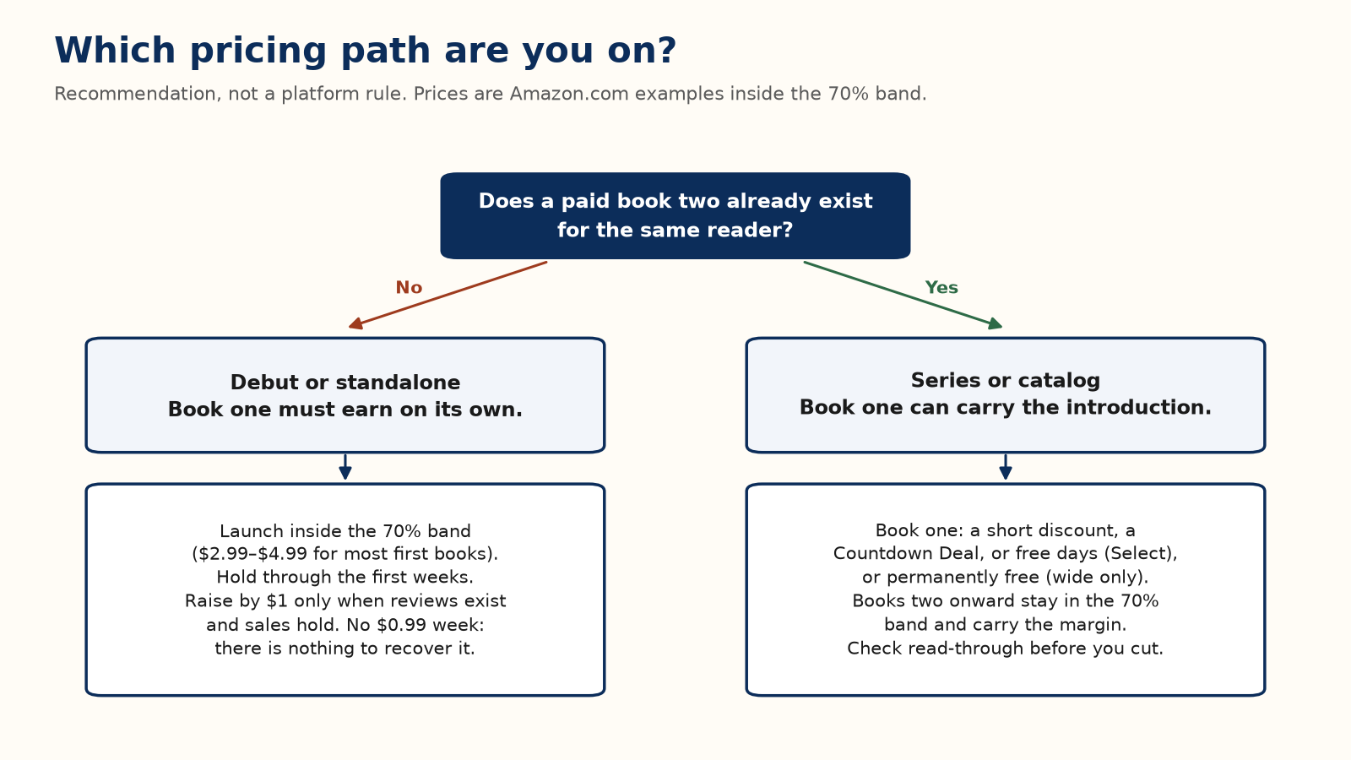
Recommendation for a debut or standalone. Launch inside the 70 percent band, usually $2.99 to $4.99. Do not launch at $0.99 unless a list or a paid promotion is ready to use it; with no sequel, there is nothing to recover the lost keep. Hold the launch price through the advance-copy window and the first weeks. Raise by $1 when a handful of specific reviews exist and sales have not depended on the low price; if sales collapse, you have found the ceiling, so go back.
Worked example. A different author raises from $3.99 (keep $2.58) to $6.99 (keep $4.68) after a strong first month, expecting more money from the same readers. Sales fall from 25 a month to 8. Before: 25 × $2.58 = $64.50. After: 8 × $4.68 = $37.44. The higher price kept less, not more — the ceiling sat somewhere below $6.99, so the honest move is back down, not a second guess at a still-higher price.
Recommendation for a series. Once book two is live, book one can become the introduction: a short discount, a Countdown Deal or free days if it is in KDP Select (Chapter 28), or a permanently free price if it is wide. Books two onward stay in the 70 percent band and carry the margin. A box set usually sits inside the band, a little under the sum of its parts. Cut book one only when read-through to book two is real; Chapter 10 has the arithmetic for checking.
Platform rule [4]. A permanently free ebook is not a price you can set on KDP. Amazon may match a lower price, including free, that it finds for the same book elsewhere, and a matched free price earns no royalty. Authors who want a permanently free book one therefore set it free at another retailer and rely on that match, which means the book cannot be in KDP Select.

Print has its own floor
KDP sets a minimum print list price so the royalty cannot go negative (Chapter 17). Treat that minimum as a floor, not a target; at the floor the royalty is close to zero. Remember also the 70 percent rule that the ebook must be at least 20 percent below the print list price.

When to move the price
- Raise when proof exists, when a sequel launches, when a promotion ends, or when comparable books on your shelf have moved. Raise a dollar at a time and wait a full week before deciding again.
- Cut for a scheduled promotion you can announce, not out of impatience on a quiet day.
- Never tie a price cut to a review. The free or discounted copy is the only concession allowed (Chapter 6).

Chapter 25: Launching Without an Audience
A launch does not need a large existing audience. It needs concentration: the reviews, the purchases from people who asked to hear from you, and any promotion you run, landing in the same short window.
Field practice. A concentrated launch is widely used because recent sales can improve a book’s place on Amazon’s best-seller and new-release lists, which are recalculated often. Amazon does not disclose the full ranking algorithm, so treat the size of the effect as unknown and do not pay for a launch on the promise of a ranking.

Pre-orders: a deadline you set for yourself
Platform rule [14]. Pre-orders are for new ebooks only. A pre-order created on or after 2 September 2026 can be set up to 18 months ahead. You can have up to 10 active pre-orders. The final manuscript must be uploaded and submitted at least 72 hours before the release date, or the pre-order is cancelled and customers are told. The first missed deadline or cancellation is forgiven once per account; a second removes your pre-order privileges for six months across the whole catalog. If you lower the price during the pre-order, earlier buyers pay the lower price.
Recommendation. Use a pre-order only for a book whose text is finished. Treat the 72-hour deadline as a date a week earlier.

Advance readers
Chapter 6 gives the review rule, and Chapter 7 the invitation. Chapter 32 covers who can post where, how to run a roster, and what to do with a bad first review. This chapter only times them: send the files two to three weeks before publication so readers can finish, and send the store link on the day reviews can be posted.

Launch week
Recommendation. Put the review link, the note to your list, and any capped ad (Chapter 9) on the same publication day rather than spreading them out. Use the six-week calendar in Chapter 11. A specific, accurate category (Chapter 23) gives a small burst of sales the best chance to be visible; it does not guarantee a badge.

Chapter 26: Amazon Ads Without Wasting Money
Chapter 9 sets the cap and the break-even click price; this chapter assumes those are on your sheet and adds campaign structure and ACOS, the figure the ads console reports.

Automatic first, manual second
Field practice. Many authors start with one automatic-targeting Sponsored Products campaign, in which Amazon chooses where to show the ad from the book’s own details. After a couple of weeks its search-term report shows which customer searches led to clicks and sales. Phrases that converted move into a manual campaign where you set each bid; phrases that spent without selling become negative keywords. The loop then repeats.

Break-even ACOS
ACOS (advertising cost of sales) is ad spend ÷ ad-attributed sales × 100%. Your break-even ACOS is keep ÷ list price × 100%. Below it, the ad pays for itself; above it, the ad costs more than it keeps. It is the same test as Chapter 9’s break-even click price, read from the other side.
Worked example. A $4.99 ebook keeping $3.28 has a break-even ACOS of 3.28 ÷ 4.99 ≈ 66%. Spend $10 and sell two copies ($9.98 in sales, $6.56 kept): ACOS ≈ 100%, about $3.44 lost. Spend $10 and sell five ($24.95 in sales, $16.40 kept): ACOS ≈ 40%, about $6.40 ahead.
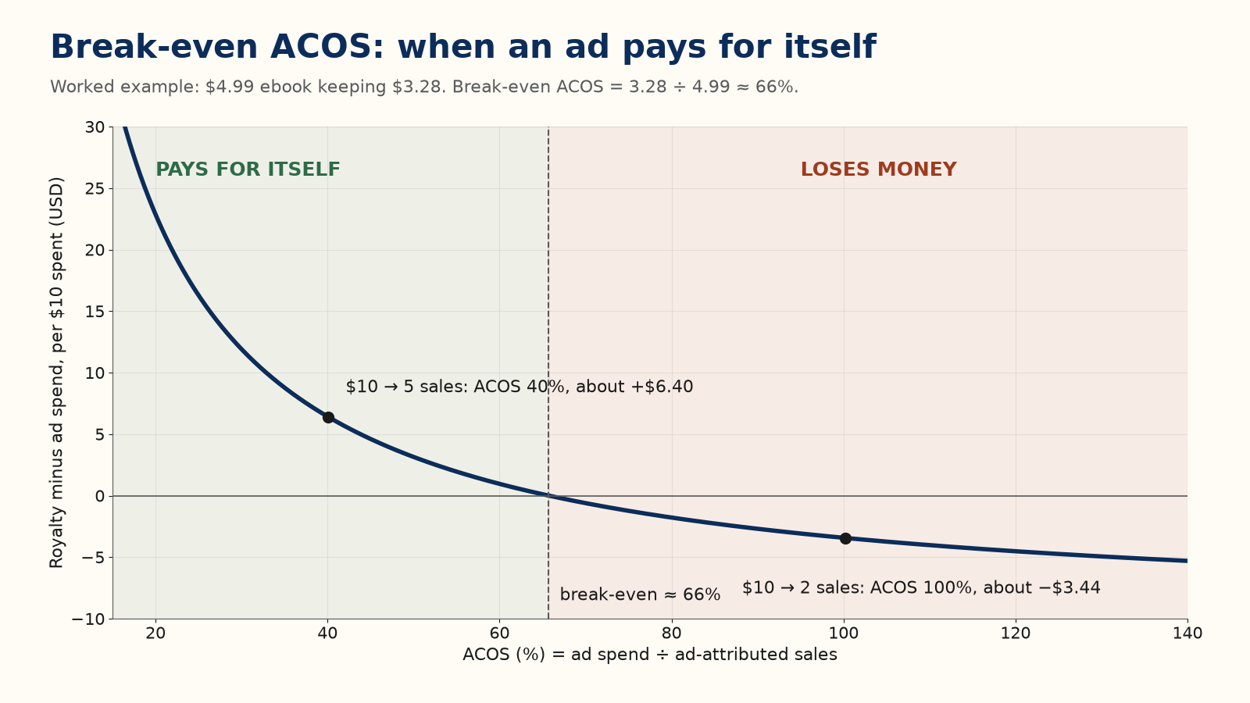
Break-even is a line, not a target. A small, deliberate loss during launch week can be a reasonable choice if it is capped and dated; the danger is running every campaign that way. If the book is part of a series, sales of later books can justify a higher ACOS on book one, but only by the read-through you have actually measured (Chapter 10).

Budget discipline
- Start with a small daily budget and let a campaign gather enough clicks to mean something before you judge it.
- Read the search-term report, not just the campaign total; one converting phrase often hides several that never sell.
- Add a search term as a negative only after it has had enough clicks with no sales to be a signal rather than chance.
- Change bids weekly, not daily; small campaigns are mostly noise from day to day.
- Keep page-read income in its own column, and do not credit the ad with every page read that week.

Part V — The Business Side

Chapter 27: Getting Paid: Taxes, Payments, and Reporting
The most common reason a first royalty payment is late or smaller than expected has nothing to do with sales: it is an incomplete tax interview. This chapter is the plumbing that makes sure the money reaches you at the rate it should.

The tax interview sets your withholding
KDP will not pay royalties until you complete its tax interview in your account settings. United States persons complete Form W-9. Non-US individuals complete Form W-8BEN, and non-US entities Form W-8BEN-E.
Platform rule [21]. Royalties from US sales are US-source income. For a non-US person the default withholding is 30 percent, taken before payment. Many countries have a tax treaty with the United States that lowers or removes that withholding on royalties, but only if you claim it in the tax interview, with a taxpayer identification number and the treaty details the form asks for. Without a valid claim, withholding stays at 30 percent. A W-8 form stays valid until the end of the third calendar year after the year you sign it; then you update your tax profile.
Recommendation. Look up your country’s current treaty entry, or ask an accountant who handles cross-border royalties, before your first sale. If your country’s tax number takes time to obtain, start now.

How and when you are paid
Platform rule [20]. KDP pays monthly, about 60 days after the end of the month in which a sale was reported, or about 90 days for paperbacks sold through Expanded Distribution: a February sale is paid at the end of April. Direct deposit has no minimum. Wire and check payments, where offered, wait until the balance reaches a threshold, for example $100 on Amazon.com, after any withholding.

Reading your reports
- The dashboard shows near-real-time estimated units and royalties. Watch a launch there; do not do your accounts from it.
- The Prior Months’ Royalties report shows final figures for a closed month, after returns and once the page-read rate is set. This is the number that matches what you will be paid.
- The Payments report shows what was actually sent to your bank, about 60 days later.
Expect the dashboard and the final report to differ a little. That is normal.

Treat it like a business
Keep a record of every expense against your royalties: editing, cover, ads, and software. Consider a separate bank account once the money is more than trivial. Whether royalty income counts as self-employment income or passive income depends on your country and on how actively you publish, and it changes what you can deduct and what you owe. That is a question for an accountant once the amounts justify it, not for a general guide.

Chapter 28: KDP Select vs. Going Wide
Once a book is ready, you decide whether its ebook is sold only through Amazon or everywhere. Neither answer is right for every book.

What Select asks for, and what it gives back
Platform rule [5] [6] [28] [13]. KDP Select is a free 90-day enrollment for ebooks only.
- For the whole term the ebook must be exclusive to Amazon: not sold, given away, or distributed anywhere else, including your own website or a bulk-emailed file. Paperback, hardcover, and audio editions may be sold anywhere.
- The ebook joins Kindle Unlimited and earns from pages read (Chapter 17).
- In each term you may run either up to five free days or one Kindle Countdown Deal, not both.
- A Countdown Deal runs only on Amazon.com and Amazon.co.uk, after the book has been enrolled for at least 30 days. On Amazon.com the list price must be between $2.99 and $24.99. The deal lasts up to seven days, the price must cut by at least $1, and the list price must stay unchanged for 30 days before and 14 days after. You keep your selected royalty rate during the deal, so a book on the 70 percent option earns 70 percent even below $2.99, minus delivery.
- Sales to Brazil, Japan, Mexico, and India earn 70 percent only for enrolled books (Chapter 17).
- The term renews automatically unless you untick renewal.
Recommendation. Put the renewal date in your calendar the day you enroll, so a decision to go wide is not made for you by default.

What going wide gives you
Going wide means selling the ebook through other retailers and library platforms, by uploading to each store yourself or through a distributor that reaches several for a share of the sales. Your income no longer depends on one platform’s rules, and some readerships buy more often elsewhere or borrow through libraries. You give up page-read income and Select’s promotions, and you manage more accounts.
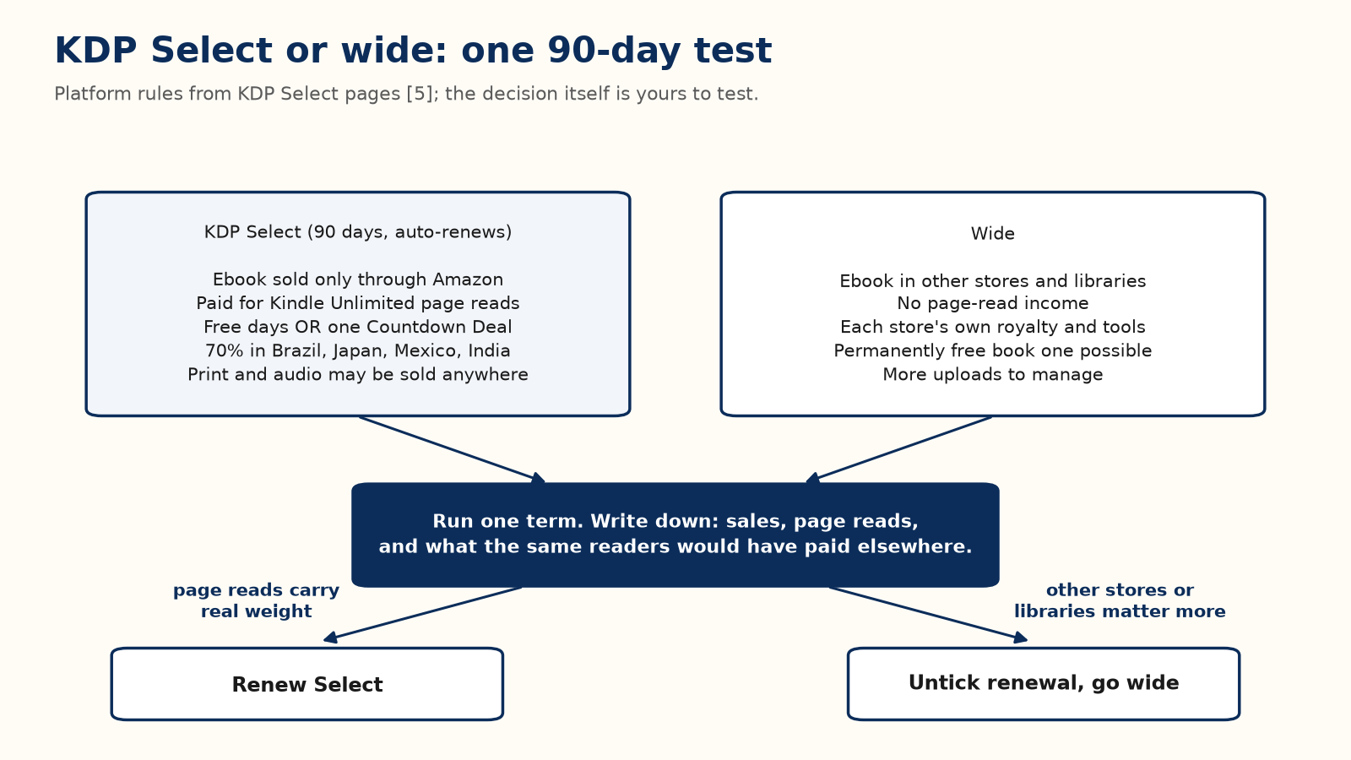

Choosing without guessing
Test it yourself. Enroll the first book for one term. Record sales, pages read, and the page-read money from the final monthly reports. At the end of the term, decide the next term from those numbers.
Worked example. A 300-page (KENP) ebook at $4.99 keeps $3.28 per sale. Suppose 300 readers in one term. If all 300 buy it, wide or in Select, the term keeps 300 × $3.28 = $984. If instead 120 of them read it in full through Kindle Unlimited at a hypothetical $0.0045 per page, the term keeps 180 × $3.28 + 120 × 300 × $0.0045 = $590.40 + $162 = $752.40. That same $752.40 is a loss or a gain depending on one fact only you can know: if those 120 would have bought the book anyway, Select cost you $984 − $752.40 = $231.60; if they would never have paid $4.99 at all, Select earned you $752.40 that wide would have earned nothing on. Select wins only if it brings readers who would not have paid $4.99 at all, and that number is exactly what one real term tells you.
Field practice. Authors widely report that Kindle Unlimited matters most for fast-reading series fiction such as romance, fantasy, and thrillers, and less for many nonfiction categories. That is a pattern, not a rule, and your own term is the only evidence that counts for your book.

Chapter 29: Avoiding the Traps
Everything in this book so far is free and documented. That is exactly what a set of scams and shortcuts is built to hide. None of the traps below requires bad intent; most are walked into by authors who meant well.

Vanity and predatory publishers
The shape repeats: a fee, from hundreds to many thousands of dollars, for things that cost nothing (an ISBN, a KDP upload, a basic conversion) or cost far less elsewhere. Warning signs:
- Unsolicited praise for a manuscript you never sent them.
- Upfront fees for “access” to distribution that KDP already gives you free.
- Vague promises of bestseller status, bookstore placement, or film interest, with pressure to sign quickly.
Freelance editors, designers, and formatters are legitimate paid services. Recommendation. Ask one question of every fee: what exactly is this paying for, and could I get that same thing done elsewhere for less? A legitimate freelancer answers at once.

Fake reviews and rank manipulation
Buying reviews, trading them, or paying for a “ranking boost” breaks Amazon’s rules (Chapter 6). Platform rule [2]. Amazon’s stated consequences for guideline violations include removing content, restricting features, suspending or terminating accounts, and withholding payments. Recommendation. No version of this trade is worth the account; the honest advance-reader method in Chapter 32 reaches the same goal.

Volume publishing and AI flooding
Mass-producing thin, lightly reviewed books to flood a category is the same trap at scale. KDP limits the pace at which an account can create titles (Chapter 15), requires disclosure of AI-generated content (Chapter 33), and may remove books that create a poor customer experience [8]. A flood of weak books under one name also damages trust in your better books, because a reader’s next click is often “more by this author.”

Copyright and licensing traps
Two mistakes recur. The first is assuming something is public domain when it is not: status depends on dates and on the country, and a translation, annotation, or edited edition of an old work can carry its own copyright (Chapter 33). The second is using an image without a licence that covers commercial use in a book. Read the licence for every image, every time.

Two triggers that need no bad intent
- Duplicate or near-duplicate content: the same book, or a lightly reworded version, under a new title, cover, or account. A relaunch that changes only the cover can look like this.
- Breaking Select exclusivity by forgetting: a book enrolled months ago, later included in a website giveaway or a bundle elsewhere (Chapter 28).
Add misleading keywords (Chapter 23) and a skipped AI disclosure (Chapter 33), and you have the common causes of account trouble that need no malice at all. Run them as a checklist before every launch.

The best filter
Many paid courses sell information that KDP’s own help pages give away. Recommendation. Before paying for any course that claims to know “the algorithm,” spend twenty minutes checking whether its claims are just KDP policy with a mark-up. Amazon does not publish its ranking algorithm, so nobody can sell it to you.

Part VI — Playing the Long Game

Chapter 30: From One Book to a Catalog
Chapter 10 has the book-two sum; this chapter assumes it and adds the other ways a catalog earns more than its books do separately.

Why a catalog outearns its parts
A reader who finishes one of your books sees your others on your author page, in “more by this author,” and in Amazon’s recommendations, at no extra marketing cost. Five related books are not five separate problems of finding readers; they are one problem followed by four chances to sell again.
The fixed costs of learning are also paid once. Learning KDP’s upload flow, your ad account, a cover style for your shelf, and how to run advance readers does not reset for book two. Field practice. Authors commonly report that a second book takes less effort to launch than the first, mostly because the learning is already paid for.
Field practice. A beginner’s hobby guide planned from the start as three short books (getting started, common mistakes, a first big project) gives each finished book a place to send its readers, instead of waiting years for one large volume. An author running two unrelated lines, say cozy mysteries and regional cookbooks, spreads risk instead: a slow month in one category does not empty the other. Both apply the same principle to different situations.

Bundles and an owned audience
A box set of existing books is a new product at almost no creation cost (Chapter 24 for its price). An email list, built from a sign-up in your books’ back matter that offers a short extra, gives you a launch audience you control instead of one that depends on Amazon’s placements. Recommendation. Start the list with book one, write to it only when you have something real to say, and never add anyone who did not ask.

Audiobooks
ACX is Amazon’s audiobook platform, distributing to Audible, Amazon, and Apple Books. There are three ways to get a finished audiobook there:
- Narrate it yourself: your time and decent recording equipment. A real option for nonfiction if your voice suits it.
- Royalty share: no upfront fee; you and the narrator split the royalty. The narrator is, in effect, betting on the book too.
- Pay per finished hour: a flat fee per finished hour of audio. You keep the whole royalty and carry the whole risk.
Worked example. At a hypothetical $300 per finished hour, a six-hour audiobook costs $1,800 upfront. Royalty share costs nothing upfront but halves every future audio royalty. Paying per hour suits a book with proven sales; royalty share suits a first audiobook on an unproven title, because it caps the downside at zero.
KDP also offers audiobooks with virtual voice, a beta that turns eligible ebooks into AI-narrated audio at little cost; check your KDP account for eligibility before planning around it. ACX pays more for exclusive distribution than non-exclusive; check ACX’s current royalty table before you choose, because it has changed before.
Not every book belongs in audio. A book that leans on charts and worked numbers, like this one, loses much of its value without the page. Narrative nonfiction, memoir, and fiction do not.

Chapter 31: A Realistic First-Year Plan
Field practice. Self-publishing income is very uneven. A small share of books and authors earn well, and a large share earn little or do not cover their costs. Nothing in this book changes that distribution. What it can change is your odds within it, by doing the plain, checkable work: real editing, an accurate category, honest reviews, capped spending, and a second book.
Recommendation. Treat the first book as tuition, not a lottery ticket. Its most valuable output may be what you learn about your shelf, your readers, and your process, which book two then applies at lower cost.

A month-by-month shape for a first book
Months | Work | Chapters
1–2 | Write, and confirm the shelf and the reader against the store before the draft is finished | 18, 2
3 | Edit, design the cover, open advance-reader sign-ups | 19, 21, 7
4 | Format, set metadata and price, launch | 20, 22, 23, 24
5–6 | Read the final reports, run a capped ad test, decide on Select renewal | 9, 25, 26, 27
7–12 | Start the next book; build the list and, once there are three books, a box set | 10, 29

The months will stretch around real life. The order matters more: research before writing, editing before launch, data before the next decision.
The honest measure of the first year is not the first royalty number. It is whether you end the year with a repeatable process and a second book under way.

Part VII — One Topic, in Depth

Chapter 32: The First-Review Problem
This chapter assumes the review rule from Chapter 6 and the invitation from Chapter 7. It takes up what those chapters left out: why reviews come before spending, who can actually post, how to run a roster of advance readers, how to deliver the file, and what to do with the first bad review.

Why proof comes before spending
A book with an empty review section asks every stranger to be the first to trust it. Field practice. Many authors find that ads and paid promotions perform poorly on pages with no reviews, and many promotional newsletters require a minimum number of reviews before they will feature a book. Amazon does not publish whether or how review count affects ranking, and this book does not guess. The case does not need a hidden formula: shoppers see the empty section, newsletter editors use it as a gate, and conversion is what turns paid clicks into kept money (Chapter 9).
So the order is: honest reviews from readers who asked to read the book, then traffic. Recruit while the file is still a draft, because readers cannot post until the book is live and cannot read a book overnight.
Field practice. Free days on KDP Select tend to produce downloads rather than reviews. A small group of readers who applied to read the book in its genre is a different population. Authors who count report much higher posting rates from such a group than from anonymous free downloads, but no published study gives a figure you can plan on. Test it yourself. Count invitations sent, files opened, and reviews posted for your own first campaign, and plan the second from that.

Who is allowed to post on Amazon
Platform rule [2] [1]. On Amazon.com a customer must have spent at least $50 on Amazon.com with a credit or debit card in the past 12 months to post a review or a star rating. Promotional discounts do not count toward the $50. Other marketplaces publish their own rules. A free copy does not make anyone eligible, and the conflict-of-interest rules from Chapter 6 still apply.
That is why a brand-new Amazon account can read your advance copy and still find the review button closed. Recommendation. Prefer advance readers who already review other books. Never tell anyone to spend money so that they can review you; that turns the review into a condition. A review from an advance copy carries no Verified Purchase badge, and that is fine. Do not ask readers to buy the live book to earn the badge, and do not refund them for doing so.
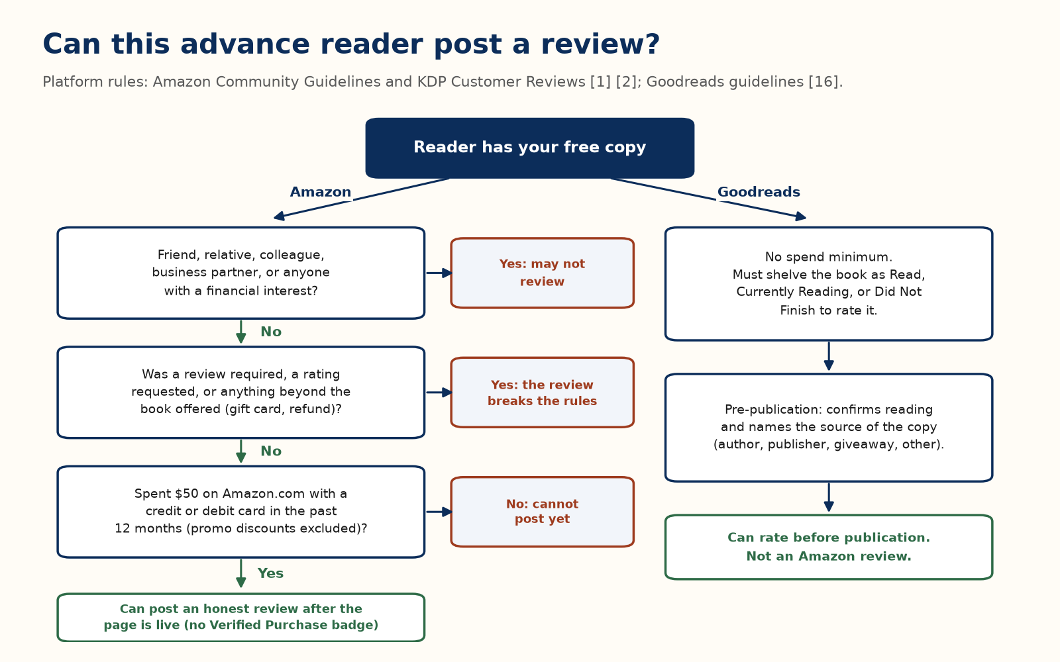

Goodreads is a different door
Platform rule [16]. Goodreads has no spend minimum and allows ratings before publication. Since its December 2025 update, a reader rating a pre-publication book must confirm they read it (a reader who did not finish may say so), is asked how they got the copy (author or publisher, a giveaway, or another source), and that source is to be shown with the review. A reader who has only shelved a book as Want to Read cannot rate it.
Treat the two sites as two jobs: Goodreads while advance readers are still reading, Amazon from the day the page is live. A Goodreads rating is not an Amazon review, and readers should never hide that their copy was free.

Running the roster
Recommendation. Treat the sign-up form as an application, not a broadcast. Ask for a name, an email, three books in your genre read in the last year, a link to an existing review profile, the device they read on, a finish-by date they agree to, and a required checkbox confirming that any review is optional and honest. Review applicants before sending anything. Share the form link, never the file.
Recruit in this order: people on your own list, then your own channels, then groups that exist for advance copies, after reading each group’s rules and posting once. If a week brings no sign-ups, post the same request in one other suitable group before concluding anything. Never fall back on relatives; they cannot review on Amazon anyway (Chapter 6).
After each campaign, track three numbers: files sent, files opened, and reviews posted. Invite back the readers who actually read and responded, whatever they thought. A long list of people who never open the file is a vanity number.

Delivering the file
Send an EPUB, not a Word file, and lock the text before anyone reads it; a review of a draft describes the draft.
Platform rule [29]. A Kindle reader can email the EPUB to their own Send to Kindle address, from an email address they have approved in their Amazon account settings, or open it in a reading app that supports EPUB.
Field practice. Delivery services such as BookFunnel exist so that you do not have to teach this to each reader. Reader-matching services such as BookSirens or Booksprout can supply readers when you have no list; NetGalley reaches librarians and reviewers. They sell downloads by interested readers, not reviews, and a review must stay optional. Recommendation. If you pay for one, use one service on one title, with a cap, and judge it by the three numbers above.

The first bad review
Platform rule [1] [2]. Amazon removes reviews that break its guidelines, for example spam, harassment, private information, conflicts of interest, or compensated reviews. A critical review from a reader who disliked the book breaks none of them and will not be removed for being negative.
Recommendation. Do not reply. A public reply stays under the review and usually reads worse than the review. If the review names a real fault, such as a broken table or a missing chapter, fix the file; that helps every later reader. A page of nothing but praise can look as if nobody felt free to be honest, so recruit for honest reactions, not unanimous ones.

A sequence that keeps the money
1. Lock the manuscript, make the EPUB, and price the ebook inside the 70 percent band (Chapters 3 and 24).
2. Open the sign-up form and send files two to three weeks before publication (Chapter 11).
3. Publish, send the review link, and hold serious ad spending until a few honest reviews exist.
4. If the roster is thin, run one capped reader-matching campaign.
5. When proof exists, raise the price by a dollar if sales hold, or hold the floor and start book two.
6. When book two exists, decide whether book one becomes the introduction (Chapter 24).
7. Only then spend on free days, newsletters, or ads.
The letters for every step are in Chapter 13. The live-page letter can link straight to Amazon’s review form, with your own ASIN in place of the placeholder: https://www.amazon.com/review/create-review?asin=YOURASIN

Claims that do not survive a spreadsheet
- That a debut should open at $0.99 to get reviews. Reviews come from people who agreed to read, not from a keep of $0.35.
- That $1.99 is a friendly compromise. It is on the 35 percent option and keeps less than $2.99 does (Chapter 3).
- That free days produce reviews. They produce downloads.
- That a hundred reviews are needed before anyone buys. The costly gap is zero.
- That reviews from family, if disclosed, are a plan. Amazon does not allow them.

Part VIII — Using AI Well

Chapter 33: Using AI Without Losing the Business
AI tools can speed up much of the work in this book. This chapter covers where they help, the exact disclosure rule, who owns what an AI writes, and the one process that looks professional but is not.

Where AI earns its place
Used as a fast first pass that a person then judges, AI is useful at most stages:
- Cover concepts (Chapter 22): rough directions to react to before a designer makes the real one. An AI-generated final cover image is AI-generated content and must be declared.
- Description and ad-copy drafts (Chapters 23 and 26): several variants for you to choose from and rewrite.
- Keyword brainstorming (Chapter 23): candidate phrases that you then test in Amazon’s search bar and check against KDP’s keyword rules.
- Research support: explaining a concept, testing your understanding, or summarising your own notes, after which you write the explanation yourself.

Building background knowledge, legitimately
Writing well about a subject you do not know cold takes research, and drawing on several kinds of sources is normal. A sound process has three steps. First, a general search to learn the current terms and questions. Second, an AI tool used as a patient colleague: “explain X,” not “condense these three books.” Third, reading the books already published on the subject, with your notes kept as private background. Close the notes before you draft, and write from what you now understand, in your own structure and with your own examples. The line is crossed when the condensed notes themselves become the draft you polish.

The disclosure rule, stated precisely
Platform rule [8]. KDP requires you to tell it about AI-generated content (text, images, or translations) when you publish a new book or edit and republish an existing one. Images include the cover and interior artwork.
- AI-generated: an AI tool created the actual content. It is AI-generated even if you edited it substantially afterwards.
- AI-assisted: you created the content and used AI tools to edit, refine, error-check, or otherwise improve it, or to brainstorm ideas. AI-assisted content does not need to be declared.
You are responsible for making sure all content, AI-generated or AI-assisted, follows KDP’s guidelines, including intellectual-property rights.
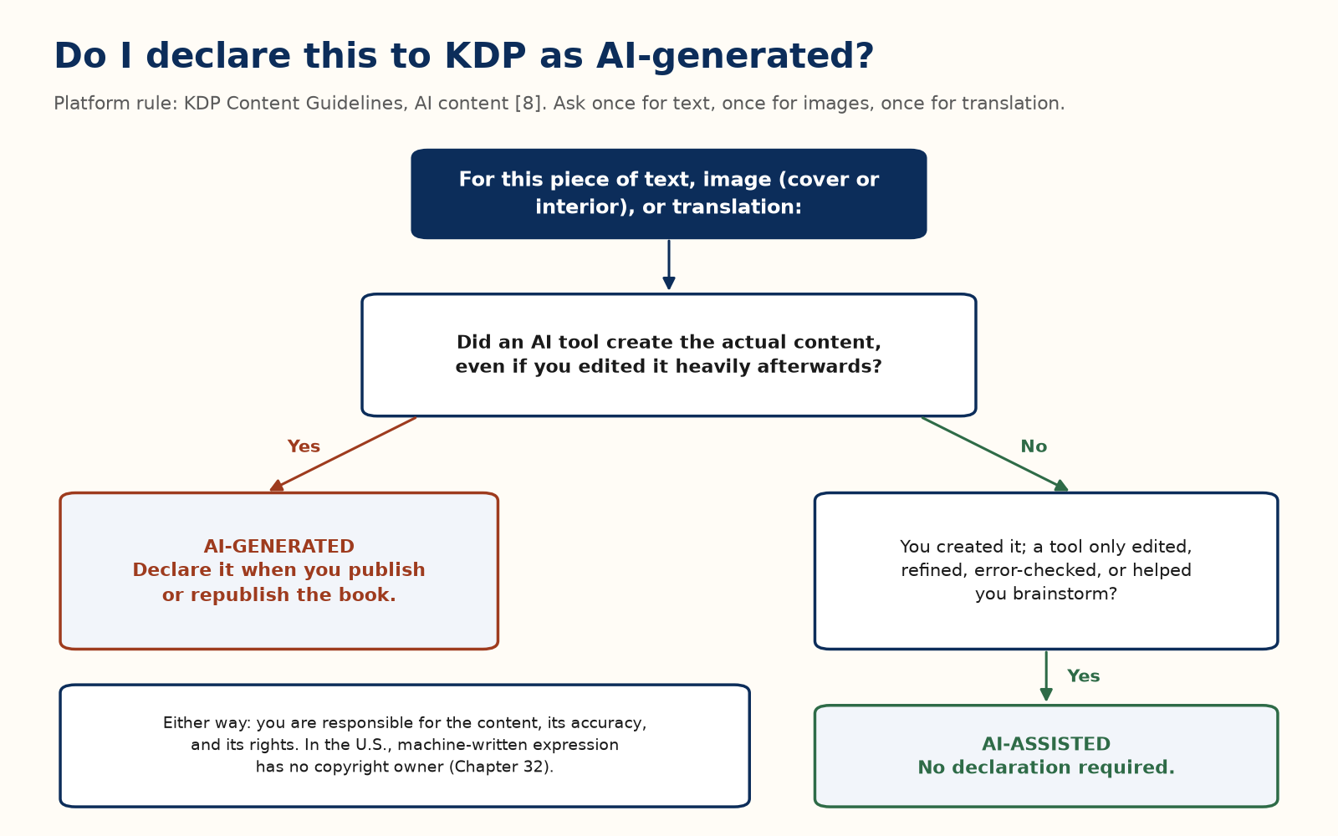
“I used AI to help me write” and “AI wrote it and I edited it” are therefore different answers, even when the pages look alike. Which one is true is a fact about how the book was made.

Who owns what the AI wrote?
Disclosure answers what Amazon needs to know. Copyright is a separate question. In the United States, copyright does not extend to purely AI-generated expression; protection for human contributions depends on what the person actually created.
Platform rule [23] [24]. U.S. copyright requires human authorship. In March 2025, the D.C. Circuit upheld the Copyright Office’s refusal to register a work generated wholly by AI in Thaler v. Perlmutter. On 2 March 2026, the Supreme Court declined to hear the appeal, leaving that circuit ruling in place. The Court’s denial was not a ruling on the merits.
That does not leave work made with AI tools unprotected. Human-authored expression can be protected within a work that also includes AI-generated material; creative modifications, selection, and arrangement may also qualify. Each case depends on the human contribution. The Copyright Office’s January 2025 report says prompts alone do not provide sufficient control over expressive elements. Other countries may use different rules; the United Kingdom, for example, has a separate provision for computer-generated works.
A tool’s terms may permit commercial use, but permission to use an output is different from copyright ownership. Even when publication is allowed, you may have no copyright-based way to stop others from copying AI-only expression.
Take a tempting case: a long, sharp conversation with a chatbot, say about whether time is real, that you want to turn into a book.
- You may. Check that service’s terms first.
- Disclose it. Every answer the AI wrote is AI-generated content, however much you trimmed it.
- Know what you own. Your questions and commentary are human-authored. Creative edits, and a sufficiently original selection or arrangement, may also qualify. AI-generated paragraphs copied as they came are not protected by copyright on their own.
- Make it yours. The more of the book you write and shape yourself, the clearer your claim to human-authored expression and the more distinctly readers hear your voice.
- Save the transcript and every draft. The service may not keep them, and dated drafts are your evidence of the human contribution.

The trap that looks like a process
One pattern deserves a name because it is packaged to look like professional workflow: take a few existing books on a subject, have AI condense and merge them, then run a “similarity audit” to find and remove close parallels with those particular sources until the draft no longer looks derived.
The audit step is the tell. Legitimate research has no reason to scrub a manuscript against a short list of specific books; that step exists because the process expects resemblance and is built to hide it. Facts and ideas are not protected by copyright, but an author’s expression of them, including wording, analogies, and structure, is [25]. A workflow whose last step erases detectable similarity to particular copyrighted books produces a derivative work dressed to pass inspection, and “an AI tool did the condensing” is no defence. It also puts the whole account at risk (Chapter 29), not just one title.

What copyright protects, and two legitimate ways to build on another work
Platform rule [25] [26] [27]. U.S. copyright protects the expression of an idea, not the idea or the facts. Fair use is decided case by case on four factors, so no single argument settles it.
None of these, on its own, makes a derivative work lawful:
- “I changed a set percentage of it.”
- “AI wrote the new wording.”
- “I credited the original author.”
- “It’s transformative.” Transformative purpose is part of one factor, not a pass.
- “It’s for education,” or “I didn’t charge for it.” Purpose and commercial use are weighed, not decisive.
- “Only the structure is the same.” Structure can be expression.
- “It’s a parody.” Parody is a narrow category that must comment on its source; the label does not create it.
There are two legitimate ways to build directly on someone else’s work: get a licence from the rights holder, or adapt a work that is verifiably in the public domain in every country where you will sell. Duration rules vary by country, and a modern translation, introduction, annotations, or cover art on an old edition can carry their own copyright. Verify the exact edition, and every layer of it, before you build on it.
General principles only, not legal advice. For a specific manuscript, ask a lawyer.

A Closing Word
Nothing in this book is complicated on its own. Royalty maths is arithmetic. Keyword slots are a form field. A launch is a calendar with the same events moved closer together. What makes self-publishing hard is that every step lands on one person, and it is tempting to skip the unglamorous ones (a real editing pass, an honest category, the tax interview) in favour of the exciting one: pressing Publish.
This book cannot promise you money, and it has tried not to. What it can promise is that every number in it can be checked: the platform rules against the dated notes, the worked examples with a calculator, and your own results against your own money sheet.
If you remember one thing, make it the keep test from the start of Part I. Before you spend money or a week, write what one sale leaves you, who the book is for and who it is not for, and the one change you will make and the day you will look. Every chapter after that is the same three lines worked out in more detail. The checklist, the royalty reference, the thirty-two ideas, and the notes follow, for the day you sit down to publish. Go write something worth finding.

Appendix A — The One-Page Launch Checklist

Manuscript
☐ Developmental, line, copy, and proofreading passes complete (Chapter 20)
☐ At least one pass done by someone other than you
☐ Every number and cross-reference checked

Format
☐ Ebook: real heading styles throughout, a linked table of contents, no page numbers or index (Chapter 21)
☐ Print: page numbers, running heads, correct trim and margins; spine and cover size from KDP’s templates (Chapter 21)
☐ Checked in KDP’s previewer on more than one device size
☐ Physical proof ordered and read, for any print edition

Cover
☐ Passes the thumbnail test at real size (Chapter 5)
☐ Follows the shelf’s conventions on purpose (Chapter 22)
☐ Title readable, one clear focal point

Metadata
☐ Seven keyword slots used as reader phrases, with no program names, no title words, and nothing misleading (Chapter 23)
☐ Three accurate categories chosen (Chapter 23)
☐ Description with no review quotes, review requests, prices, time-limited claims, or links (Chapter 23)
☐ Price set on purpose inside, or knowingly outside, the 70 percent band (Chapters 3 and 24)

Compliance
☐ Tax interview completed and treaty claimed if it applies (Chapter 27)
☐ AI-content question answered truthfully (Chapter 33)
☐ KDP Select enrolment, and its renewal date, decided on purpose (Chapter 28)

Launch
☐ Advance readers recruited and files sent two to three weeks ahead (Chapters 7, 11, and 31)
☐ Every request for a review says it is optional and asks for an honest one (Chapter 6)
☐ If running ads: keep, conversion assumption, cap, and stop date written first (Chapters 9 and 26)

Appendix B — Royalty Quick Reference
Platform rules on Amazon.com, checked 5 October 2026. Check the live pages before you act [3] [4] [7] [13] [19].
Item | Rule
Ebook, 70% option | List price $2.99–$12.99 and at least 20% below the print list price. Royalty = 0.70 × (price − VAT − delivery). Delivery $0.15 per MB on Amazon.com.
Ebook, 35% option | Royalty = 0.35 × (price − VAT), no delivery charge. Minimum price $0.99 under 3 MB, $1.99 for 3–10 MB, $2.99 for 10 MB and over; maximum $200.
Ebook, always 35% | Public-domain works; a sale price-matched below the 70% band.
Ebook, 70% only in Select | Sales in Brazil, Japan, Mexico, and India.
Kindle Unlimited | Share of a monthly fund by KENP pages read for the first time, up to 3,000 pages per title per customer. No fixed rate; July 2026 fund $67.6 million [10].
Paperback, Amazon | 60% of list price at $9.99 and above, 50% below, minus printing cost.
Paperback, Expanded Distribution | 40% of list price, minus printing cost.
Hardcover, Amazon | 60% at $9.99 and above, 50% below, minus printing cost.
Hardcover, Expanded Distribution | Not offered; hardcovers sell only directly through Amazon.
Printing cost | Depends on marketplace, page count, and ink; for hardcover, also trim size. Use KDP’s calculator.
Payment | About 60 days after month end (90 for Expanded Distribution) [20].

The two formulas worth remembering:
- Break-even cost per click = keep × conversion rate (Chapter 9).
- Break-even ACOS = keep ÷ price × 100% (Chapter 26).

Appendix C — ISBNs, Wide Distribution, and Further Reading

ISBNs
KDP does not require you to buy an ISBN. A Kindle ebook needs none; Amazon identifies it with an ASIN. A paperback or hardcover needs an ISBN, and KDP can assign one free when you publish. Anyone charging a fee “so you can get an ISBN and publish” is billing you for something KDP gives away (Chapter 29).
A free KDP ISBN lists the publisher as “Independently Published” and can be used only for KDP print. Buying your own, from Bowker in the United States or your country’s ISBN agency elsewhere, lists you or your imprint as publisher and lets you print the same edition elsewhere. For a book that stays with KDP print, the free ISBN is a reasonable choice.

Wide distribution
If you go wide (Chapter 28), you can upload to each retailer directly (for example Apple Books, Kobo, and Barnes & Noble Press) or use a distributor that reaches several retailers and library platforms from one upload; Draft2Digital and PublishDrive are widely used examples. IngramSpark is a common choice for wider print distribution to bookshops and libraries.

Further reading
KDP’s own help pages are the authoritative, free, continuously updated source. When a figure in this book disagrees with them, trust the help page; the arithmetic in this book still works with the new figure.
Author communities are a good source of current experience. Read them as Chapter 29 recommends: ask whether a claim is a documented rule or a theory about the algorithm.
For tax questions specific to you, a professional who handles royalty or cross-border income (Chapter 27).

Appendix D — Thirty-Two Ways a Book Can Pay You
Chapter 8 asks you to pick three of these: one price, one next book, one format or extra. Run each through the same four steps:
1. Write the keep for that product, from Chapter 3 or KDP’s estimate.
2. Do the smallest version that can teach you something.
3. Write down the day you will look, two or four weeks out, before you start.
4. On that day, keep it or stop it, in one sentence on the money sheet. Do not start the next idea until that sentence exists.
Each idea gives the smallest version and the sign to stop. Keeps are the Chapter 3 worked examples (2 MB file, no VAT); your own estimate wins. All are Recommendations unless marked otherwise.

Price
1. Charge a real ebook price. Smallest version: change only the price, to one inside the 70 percent band, for four weeks. Stop if the keep on the sheet falls.
2. Make book one the introduction. Smallest version: write both books’ prices on one line (Chapter 24). Stop if book two still has no date.
3. Run a short Countdown Deal, then restore the price. A Select book only, under the rules in Chapter 28 [6]. Smallest version: one deal, with the morning the full price returns written down. Stop if book two is not linked.
4. Make book one free only when book two is live. A free download keeps $0. Smallest version: book two live and linked, then free days [28]. Stop if book two is not live.
5. Revisit each price once a year. Smallest version: the current keep of the oldest book, on the sheet. Stop if you find yourself changing prices every month.

The next book
6. Write the next book while this one is warm. Smallest version: one sentence at the end of book one saying who book two is for. Stop if that sentence describes book one again.
7. Use a series page. Smallest version: two finished books, each linking to the other. Stop if a reader of book one would not want book two next.
8. Sell a box set after three books. Three sales at $3.99 keep about $7.74; a set at $7.99 keeps about $5.38 — less, but only for a reader who would have bought all three anyway. A box set’s real job is the reader who would have bought none of them at full price. Smallest version: three finished files and that sum. Stop if the set’s keep is one you would not accept.
9. Open a pre-order you can finish. Rules in Chapter 25 [14]. Smallest version: a date and a file that is already done. Stop if the file is not done.
10. Write one seasonal short. Smallest version: the season and the date it must be on sale. Stop if that date has passed.
11. Publish a second edition for a real reason. Smallest version: three fixes a past reader would be glad to hear about. Stop if you cannot name three.

Formats and extras
12. Add a paperback. Keep = rate × list price − printing cost (Chapter 17). Smallest version: one price in KDP’s calculator, then a proof. Stop if the keep is below the ebook’s and nobody has asked for paper.
13. Add large print. Smallest version: copy the paperback setup with larger type and rerun the calculator. Stop if the keep falls below the ebook’s.
14. Add a hardcover. Smallest version: one price in the calculator. Stop if the keep is below the ebook’s, or you have not yet held a paperback proof.
15. Price a paperback libraries can buy. Worked example. At $14.99 with a hypothetical $4 printing cost, Amazon’s 60 percent keeps about $5 and Expanded Distribution’s 40 percent about $2. Smallest version: one Expanded Distribution price and its keep. Stop if printing cost eats the keep.
16. Record audio after the ebook has readers (Chapter 30). Smallest version: ask readers who finished whether they would listen. Stop if they would not.
17. Translate one book that already sells. Smallest version: one chapter checked by a fluent reader before paying for the rest. Stop if the book has no readers yet.
18. Sell a workbook beside the main book. Smallest version: ten prompts that are not already chapters. Stop if you cannot list ten.
19. Sell a one-sitting extra, such as a field guide or troubleshooting list. Smallest version: one sentence and a price in the 70 percent band. Stop if you cannot say it in one line.
20. Sell a template pack from your own site. Smallest version: the file names and the price. Stop if the book would not stand alone without it.
21. Give away a short extra, not the whole book. Smallest version: the extra outlined on one page. Stop if the paid book’s first two lines are not done.

Reach
22. Choose a shelf where you can be seen. Smallest version: one accurate category and the five books on it (Chapter 23). Stop if those five are not books your reader buys.
23. Put the promise in the first two lines of the description (Chapter 4). Smallest version: show them to one stranger. Stop when that person can say who the book is for.
24. Try Kindle Unlimited on purpose (Chapter 28). Smallest version: read the terms and write the renewal date. Stop at day 90 if page-read money did not replace the sales you gave up.
25. Sell the ebook in more than one store when not in Select. Smallest version: one other store and its royalty page. Stop while you are inside a Select term.
26. Open one more Amazon marketplace price. Smallest version: one country where your reader lives, with its own price and estimate. Stop if you are about to change five countries on one day.
27. Write to readers who asked (Chapter 30). Smallest version: one sentence in the back of the book and one place to join. Stop if you never write to them.
28. Offer the book to a group you already know, such as a club or a class. Smallest version: one letter to one group. Stop if the offer has to promise reviews, grades, or income.
29. Teach the chapter once. Smallest version: a one-hour outline and a fee. Stop if you cannot name ten people who would care.
30. Share a bundle or a mention with one other author. Smallest version: one book you would hand your own reader. Stop if you have not read it, or the other author wants a review swap.
31. Spend on ads only after the keep is written down (Chapter 9). Smallest version: the keep line filled before you open the ads console. Stop if that line is blank.
32. Leave the old books up, working. Smallest version: open each live sample on your phone. Stop leaving a book up when its sample is broken: fix it that week or unpublish it.
Leave these for later: merchandise, paid fan clubs, and large courses with no audience. They add work and rarely add a keep until strangers already want the book.

Glossary
One line each, with the chapter that teaches the word.
ACOS. Advertising cost of sale: ad spend divided by ad-attributed sales. Chapter 26.
Advance copy. A free copy sent before publication; any review stays optional. Chapters 6 and 32.
ASIN. Amazon’s identifier for a product, including a Kindle ebook. Appendix C.
Backlist. Books you published earlier and left on sale. Appendix D.
Countdown Deal. A scheduled, time-limited price cut for KDP Select books on Amazon.com and Amazon.co.uk. Chapter 28.
Delivery cost. A per-megabyte charge taken off the price before the 70 percent royalty; not charged on the 35 percent option. Chapter 3.
Expanded Distribution. KDP’s wider paperback channel to other retailers and libraries, at a lower royalty rate. Chapter 17.
Keep. What one sale leaves you after Amazon’s share and, where it applies, delivery. Chapter 3.
KENP. Kindle Edition Normalized Pages, the page count Amazon uses to pay Kindle Unlimited reads. Chapter 17.
KDP Select. A 90-day, ebook-only exclusive enrolment that adds Kindle Unlimited and promotions. Chapter 28.
Seventy percent band. On Amazon.com, list prices from $2.99 to $12.99 where the 70 percent royalty can apply. The top was $9.99 until 7 July 2026. Chapter 3.
Thumbnail test. Whether the title can be read when the cover is shown tiny. Chapter 5.
VAT. Value-added tax, charged on ebook sales in some marketplaces outside the United States and subtracted before the royalty percentage is applied. Chapter 3.

Notes
Every note was checked on 5 October 2026. Platform pages change; look again before you act. Worked examples, field practice, and recommendations in this book are not Amazon rules and are not sourced to these pages.
[1] Amazon KDP Help, “Customer Reviews.” https://kdp.amazon.com/en_US/help/topic/G202101910
[2] Amazon, “Community Guidelines.” https://www.amazon.com/gp/help/customer/display.html?nodeId=GLHXEX85MENUE4XF
[3] Amazon KDP Help, “eBook List Price Requirements.” https://kdp.amazon.com/en_US/help/topic/G200634560
[4] Amazon KDP Help, “Digital Book Pricing Page.” https://kdp.amazon.com/en_US/help/topic/G200634500
[5] Amazon KDP Help, “KDP Select.” https://kdp.amazon.com/en_US/help/topic/G200798990
[6] Amazon KDP Help, “Kindle Countdown Deals.” https://kdp.amazon.com/en_US/help/topic/G201293780
[7] Amazon KDP Help, “Paperback Royalty.” https://kdp.amazon.com/en_US/help/topic/G201834330
[8] Amazon KDP Help, “Content Guidelines.” https://kdp.amazon.com/en_US/help/topic/G200672390
[9] Amazon KDP Help, “Kindle Publishing Guidelines.” https://kdp.amazon.com/en_US/help/topic/GU72M65VRFPH43L6
[10] KDP Community, “KDP Select Global Fund and All Stars Bonus Update – July 2026.” https://www.kdpcommunity.com/s/article/KDP-Select-Global-Fund-and-All-Stars-Bonus-Update---July-2026
[11] Amazon KDP Help, “Create a Book” (title creation limit). https://kdp.amazon.com/en_US/help/topic/G202172740
[12] Amazon KDP Help, “Digital Rights Management (DRM).” https://kdp.amazon.com/en_US/help/topic/GDDXGH9VR22ACM8U
[13] Amazon KDP Help, “Royalties in Kindle Unlimited.” https://kdp.amazon.com/en_US/help/topic/G201541130
[14] Amazon KDP Help, “Pre-Order.” https://kdp.amazon.com/en_US/help/topic/G201499380
[15] Amazon KDP Help, “Categories.” https://kdp.amazon.com/en_US/help/topic/G200652170
[16] Goodreads Blog, “Improving Ratings and Reviews on Goodreads: Updated Guidelines for Pre-Publication Books,” 15 December 2025. https://www.goodreads.com/blog/show/3057-improving-ratings-and-reviews-on-goodreads-updated-guidelines-for-pre-p
[17] Amazon KDP Help, “Metadata Guidelines for Books.” https://kdp.amazon.com/en_US/help/topic/G201097560
[18] Amazon KDP Help, “Keywords.” https://kdp.amazon.com/en_US/help/topic/G201298500
[19] Amazon KDP Help, “Hardcover Royalty.” https://kdp.amazon.com/en_US/help/topic/G77F3WPD3KQLJTFS
[20] Amazon KDP Help, “When Will I Get Paid?” https://kdp.amazon.com/en_US/help/topic/GK2MKZUL6U3SFBPZ
[21] Amazon KDP Help, “Tax Withholding.” https://kdp.amazon.com/en_US/help/topic/G201274690
[22] U.S. Federal Trade Commission, “Consumer Reviews and Testimonials Rule: Questions and Answers.” https://www.ftc.gov/business-guidance/resources/consumer-reviews-testimonials-rule-questions-answers
[23] Supreme Court of the United States, docket 25-449, Thaler v. Perlmutter (certiorari denied 2 March 2026). https://www.supremecourt.gov/docket/docketfiles/html/public/25-449.html
[24] U.S. Copyright Office, Copyright and Artificial Intelligence, Part 2: Copyrightability, January 2025. https://www.copyright.gov/ai/Copyright-and-Artificial-Intelligence-Part-2-Copyrightability-Report.pdf
[25] U.S. Code, Title 17, Chapter 1, § 102 (subject matter of copyright). https://www.copyright.gov/title17/92chap1.html
[26] U.S. Copyright Office, “Fair Use Index.” https://www.copyright.gov/fair-use/
[27] U.S. Copyright Office, Circular 15A, “Duration of Copyright.” https://www.copyright.gov/circs/circ15a.pdf
[28] Amazon KDP Help, “Free Book Promotions.” https://kdp.amazon.com/en_US/help/topic/G201298240
[29] Amazon Help, “Send to Kindle.” https://www.amazon.com/gp/help/customer/display.html?nodeId=G7NECT4B4ZWHQ8WV
[30] Amazon KDP Help, “Write a Book Description.” https://kdp.amazon.com/en_US/help/topic/G201189630

About the Author
Kevin Drew Peters is a graduate of Munich University of Applied Sciences. He spent many years in the semiconductor industry, mostly in the United States, supporting several start-ups, where a decision was only as good as the measurement behind it and a budget was a hypothesis until the numbers came back.
He brings that habit to publishing. That is why this book shows the arithmetic, labels every claim by kind, dates its sources, and treats every change as a bounded experiment with a cap and a stop date. He does not claim insider knowledge of Amazon’s algorithms, and this book reports no publishing results it cannot show.
Independent guide. Not affiliated with or endorsed by Amazon. Check the live help pages before you act.

Also by Kevin Drew Peters
Physics, Actually
- Physics, Actually, Volume 1: Motion, Forces, Time, and Relativity
- Physics, Actually, Volume 2: Gravity, Cosmology, and the Limits of Spacetime
- Physics, Actually, Volume 3: The Standard Model, Chaos, and the Edge of Knowledge
- Life, Actually: From the First Cell to the Edited Genome and the Search for Life Elsewhere
Math, Actually
- Math, Actually, Volume 1: From Arithmetic to Calculus
- Math, Actually, Volume 2: From Multivariable Calculus to Set Theory & Logic
- Math, Actually, Volume 3: From Differential Equations to Abstract Algebra
- Math, Actually, Volume 4: From Category Theory to the Frontier
Quantum, Actually
- Quantum, Actually, Volume 1: Questions and Answers from the Double Slit to the Superconducting Wire
- Quantum, Actually, Volume 2: A QED Course
Science Sparks
- Science Sparks: Physics, Life, and Mathematics — The Same Few Rules, Told in Highlights
Look First
- Look First, Volume 1: The Universe Has No Now
- Look First, Volume 2: A Trip Is Not a New Life
Electrical Engineering Series
- Foundations of Electronics (Book 1)
- Circuits, Components, and Control (Book 2)
- Semiconductor Physics and Devices (Book 3)
- RF, Microwave, and Transceivers (Book 4)
- Communications, Wireless, and SDR (Book 5)
- Power and Energy (Book 6)
- Packaging, Layout, EMC, and Test (Book 7)
History
- The Dolphins’ View of History
Fiction
- The Murder That Hadn’t Happened Yet (The Relativistic Investigation Bureau, Book 1)
- The Warning That Was Sent Too Late (The Relativistic Investigation Bureau, Book 2)
- Schrödinger’s Paperwork (Lolly Wren’s Curious Science Adventures, Book 1)
- The Permitted Options (Lolly Wren’s Curious Science Adventures, Book 2)
- Protocol Flamingo (The Invasion Storybooks, Book 1), as George Herbert Fontaine
How-To
- Your First Book That Sells
- Your First YouTube Channel That Rocks

